Appendix I:

"gen_code.exe": Genetic Code Analysis Program

Contents

1 Overview ii
1.1 Introduction ii
1.2 Program overview ii
1.3 Necessary auxiliary data files iii
2 External Documentation iii
2.1 Setting parameters prior to an analysis iii
2.2 Manipulating the results file once analysis is complete viii
2.3 Changing amino acid parameters xi
2.4 File creation xii
3 Internal Documentation xiii
3.1 Fundamental data structures xiii
3.2 Program structure xiii
3.3 Source code overview xv
3.4 Source Code xvii

1 Overview

1.1 Introduction
The results presented in chapters 3, 4, 5 and section 6.1 and 6.2 were produced using program "gen_code.exe", an ANSI 'C' program developed with Microsoft Visual C++© programming language on a PC computer. A pre-compiled copy of this program, together with necessary auxiliary data files (section 1.3), and ASCII source code files is found in directory "gen_code" of the 3.5" floppy disk at the back of this thesis.
The program may be compiled from source code using any ANSI 'C' compiler. The file to compile is "main.c", which calls numerous other files in pre-processor directives. The program contains 1 platform specific function (function List_Files, found in file gen_io.c) which may not work under operating systems other than DOS (version 3.0 or above). These functions are not important to the fundamental working of the program (merely allowing the saving and loading of alternative genetic codes created using the program) and should ideally be disabled before attempting to compile and run the program under any other environment. Both functions use the ANSI 'C' command 'system' to send DOS instructions to the operating system: the program may be run on other platforms so long as the user does not elect to save or load genetic codes to a file (section 2.2b).
To run the pre-compiled program, the directory contents should be copied onto a hard-disk with plenty of free space, as the program may produce large temporary data storage files under certain settings (section 2.4)

1.2 Program overview
Program "gen_code.exe" allows analysis of code optimality under different assumptions. The program is essentially linear: initially the user is given the chance to define a particular analysis, the analysis is performed, the results file written, and the program ends.
The user first defines a particular code structure (default of the canonical code), defines parameter ranges (such as a transition/transversion bias, or range of such biases, and a modular power function or range of powers), defines possible code variation (the 'unrestricted' or 'restricted' set of possible codes) and a method of optimality testing (% error minimisation or proportion of better codes found: see chapter 5). When satisfied with the settings, the user elects to run the analysis, after which user input ceases.
Once analysis is complete, the program will generate an ASCII results file, which contains a log of all information used to create the analysis, together with analysis results. This text file may be opened by Excel or most other graphing and spreadsheet packages for further manipulation and graphical presentation of results (section 2.2).

1.3 Necessary auxiliary data files
Program "gen_code.exe" should only be used when necessary auxiliary data files are present. In the absence of such files, the user will be prompted to enter alternative file and path names. If no suitable alternatives exist, the user will be required to terminate the program.
For the program to run, the following files must be present in the same directory (this is a minimal requirement):

File Name Description
gen_code.exe the program file
matrix_f.cod a text file describing the canonical code
a_acid_f.txt a text file containing Polar Requirement values for the 20 amino acids
PAM74100.txt a text file containing PAM 74-100 entries for the 20 amino acids

In addition, other "*.cod" files may be present, representing alternative genetic code structures which have been created and saved during previous sessions with the program. In particular, chapter 6 (section 6.1) considers analysis of the S. cerevisiae mitochondrial code, which is included on the floppy disk at the back of this thesis (file "yeastmt.cod").

2 External Documentation
As noted above, user interaction with the program occurs at two stages. First, within the program, the user is required to start a particular analysis, and is given the option to change most analysis settings prior to doing so. Second, once the program has finished, the user is required to open the ASCII results file in a spreadsheet or graphing package if further data manipulation or graphical representation is required.

2.1 Setting parameters prior to an analysis
On starting the program, the user will be faced with a description of current analysis parameter settings (initially set to default values), and a list of options for altering these settings, or starting the analysis (figure 1a). The description of current settings is displayed in the top half of the screen, and the options for changing them in the bottom half. This screen will re-appear when any changes are made, but is rendered inactive when the user elects to start an analysis. Throughout the following section, words in italics are to be found in the program display. Words in underlined italics are to be typed in by the user.

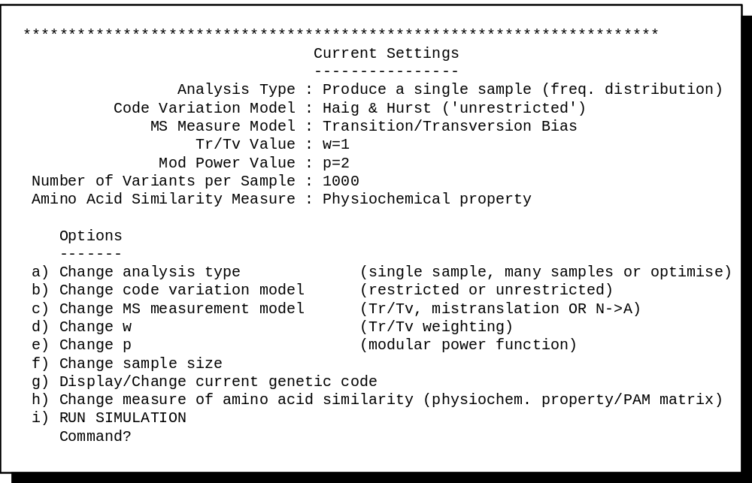
Figure 1a The introductory screen of program "gen_code.exe".

2.1a Description of current parameter settings (top half of screen)
Analysis Type refers to the type of code analysis to be undertaken. The user may choose one of three options: Produce single sample (default setting) allows the user to specify a single point in parameter space (i.e. a single transition bias and a single modular power function), such that a large sample of random variant codes is produced and written to the results file as a frequency distribution. This option was used to create figures 3.1, 3.5 and 5.4. Produce many samples allows the user to specify a range of transition biases, and a range of modular power functions, such that large samples of random variant codes are produced, and the number of 'better' codes in each sample is stored and written to the results file to form a table of results (section 2.2). This option was used to create figures 3.3, 3.4, 3.7, 4.3, 4.4, 5.2a, 5.3a and 6.2. Finally, Optimize Code Structure uses the Great Deluge Algorithm (GDA: see chapter 5) to estimate the best possible code structure for any particular set of parameters, over a range of transition biases and modular power functions. This optimisation is necessary to estimate the % distance minimisation measure of code optimality, and was used to create figures 5.2b,c and 5.3b,c.
Code Variation Model refers to the set of rules defining possible code structures. Whichever analysis type is chosen, the user may elect to consider the unrestricted set of codes (default setting; first used by Haig and Hurst, 1991) or the restricted set of codes (defined according to rules of biosynthetic restrictions, described in chapter 4).
MS Measure Model refers to the weighting regime to be applied when calculating code error values. Transition Bias applies a weighting variable to transition errors (see chapters 3 and 5), and was used to create figures 3.3, 3.7, 4.3, 5.2a,b,c, 5.3a,b,c, 5.4, and 6.2, 6.5. Mis-translation applies the estimation of mistranslation parameters used to create figures 3.4 and 4.4 (see chapter 3). A third setting, N->A has not been used in this thesis, but represents an alternative weighting model which may be applicable to mitochondrial code analysis (or indeed analysis of codes used by any extreme GC content genomes: see chapter 6.3), in that it applies a unidirectional weighting to errors from any base (N) to a purine (A or T). This aspect is currently under development.
Tr/Tv Value indicates the current transition weighting (see chapters 3 and 5). Where Analysis Type is set to Single Sample, this will be a single value. For any other analysis type, this will be a range of values, represented by the upper and lower boundaries. A transition weighting of 1 (default setting) indicates that transitions and transversions are weighted equally, as used to produce figures 3.3 and 4.3.
Mod. Power Value indicates the current modular power function (see chapter 5). A modular power value of 2 (default setting) indicates that mean squared change in amino acid similarity is to be used. This setting was used throughout chapters 3 and 4.
Number of Variants per sample indicates the size of the sample of random variant codes to be generated. This option is not applicable to the Optimize Code Structure option under Analysis Type. Most of the figures used in this thesis consider a sample size of 1 million random variant codes.
Amino Acid Similarity Measure allows the user to choose either Polar Requirement (see chapter 3) or transformed PAM 74-100 matrix data (see chapter 5). Any other amino acid physiochemical property or PAM matrix data set may be used if it is available in the correct ASCII format (section 2.3),

2.1b Changing current parameter settings (bottom half of screen)
Any of the default settings described above may be changed by the user prior to executing an analysis. The general procedure is straightforward: each setting is denoted by a letter under "Options" in the lower half of the screen. Whenever the program displays current settings (figure 1a), the question "Command?" followed by a blinking cursor will appear at the bottom of the screen. The user may thus select a parameter to alter by entering the appropriate letter (a to j), followed by .
For example, to change the type of analysis to be undertaken, the user would enter a at the display of current settings screen (figure 1a), which would bring up a sub-options screen (figure 1b). At the top of this sub-screen, the current setting (in this case Produce a single sample) is displayed, and underneath are listed the various options, each associated with a number. Thus, to change the current analysis type to Produce Many samples, the user would enter 2 followed by . All other options are similarly self explanatory, with 2 exceptions. First, electing to use the restricted set of codes causes the program to reload the canonical genetic code, since other structures violate the biosynthetic rules which define the restricted set of codes. Second, option g: Change/Display current
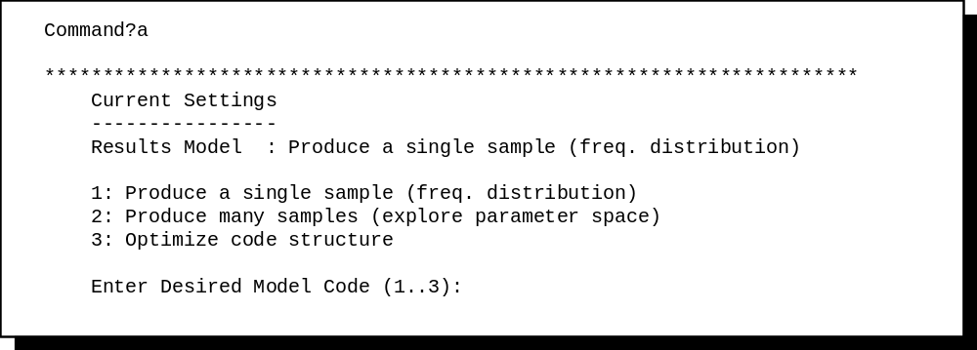
Figure 1b The sub-menu resulting from choosing option a: Change analysis type from the 'current settings' display screen.

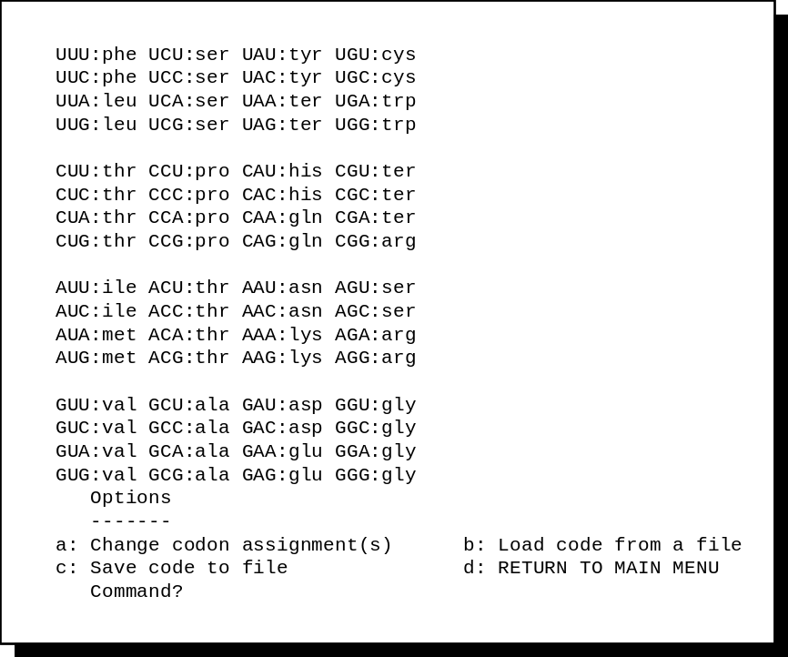

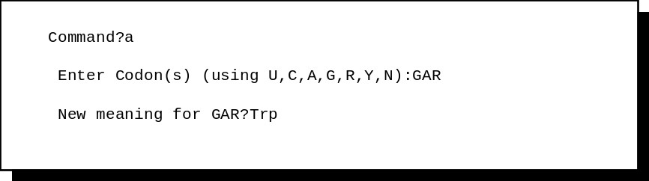
Figure 1c (i) The sub-menu resulting from choosing option g: Display/Change current genetic code from the 'current settings' display screen (ii) an example of codon reassignment: in this case, codons GAG and GAA would assume the meaning Trp.

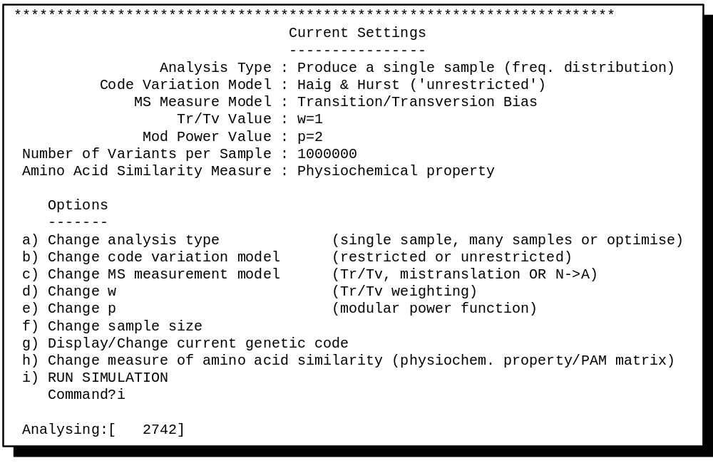
Figure 1d Analysis in mid progress: the program is analysing the 2,742nd variant of a sample of 1 million codes

genetic code is also more complex. Selecting this option will bring up a display of the current genetic code structure stored in memory, and allow the user to manipulate this structure, load an alternative from a file or save a manipulated code to a file. This basic display is shown in figure 1c(i). Choosing option c: Save code to file will produce a prompt: enter filename (NO EXTENSION!), thus for example, if code structure has been manipulated to show the yeast mitochondrial code, a suitable name would be yeastmt. Choosing option b: Load code from file will produce a listing of eligible files, from which the user is able to select. Choosing option a: Change codon assignments leads to two successive prompts (figure 1c(ii)). The first asks the user to input codon(s) which are to be re-assigned. Here, the user must respond with a 3 letter input of the form 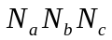 followed by . The user is able to specify a single codon, such as CGA, or a range of codons, such as AUN or GYU. In fact any of the standard nucleotide notations ('U', 'C', 'A', 'G', 'R', 'Y' or 'N') may be used at any codon position.
Once the user has defined parameter settings to his satisfaction, selecting option i from the current settings display (figure 1a) will start the analysis. Progress of the analysis is marked by a counter at the bottom of the screen (figure 1d), which displays the number of genetic code variants considered so far. Some analyses may be lengthy. For example, to analyse a sample of 1 million genetic codes over a transition weighting of 1 to 5 and a modular power function of 1 to 5 (e.g. to produce figures 5.2 and 5.3) takes approximately 6 hours on a Pentium II 233 MgHz. This may seem excessive until it is realised that this analysis requires something in the region of 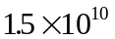floating point calculations (ignoring the generation of random codes, storage of data etc.): the program is actually highly optimised for speed!
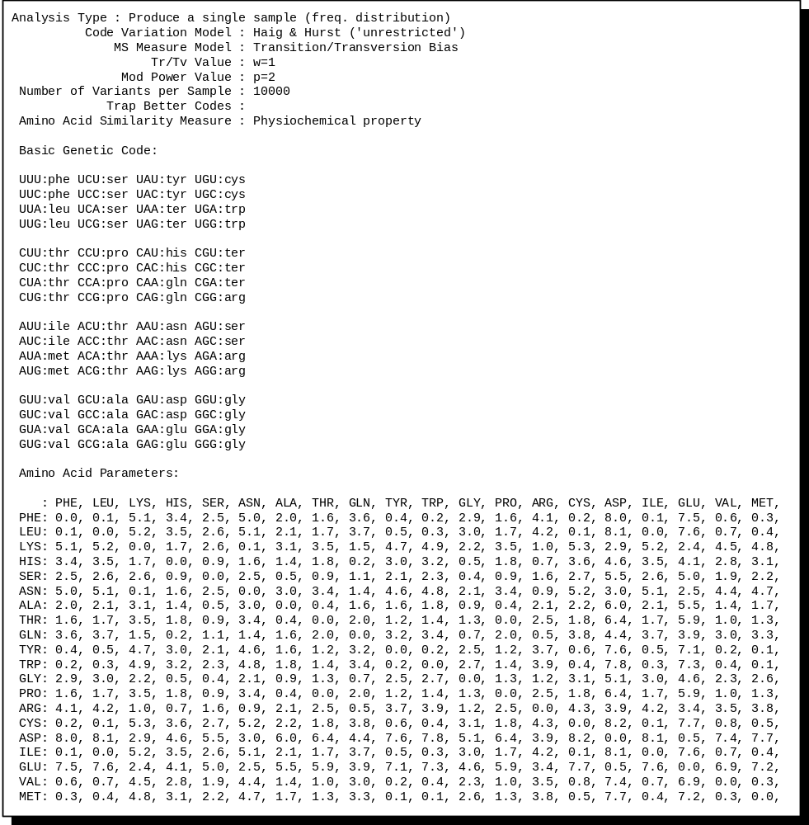
Figure 1e The first section of the ASCII results file: parameter settings.

2.2 Manipulating the results file once analysis is complete
Once analysis has finished, a ASCII results file is written in the same directory from which the
program was run. This file takes the name "results.txt" and, in addition to containing the analysis results, contains all information pertaining to the parameter settings used in the analysis. The file is divided into 2 sections: the first details parameter settings, the second details the results obtained.
The first section (figure 1e) starts with a summary of the 'current settings screen': a broad overview of the analysis undertaken. This is then followed by a printout of the genetic code used as the starting point of the analysis. Finally in this section is a printout of the modular, unweighted difference represented by a change between each pair of amino acids
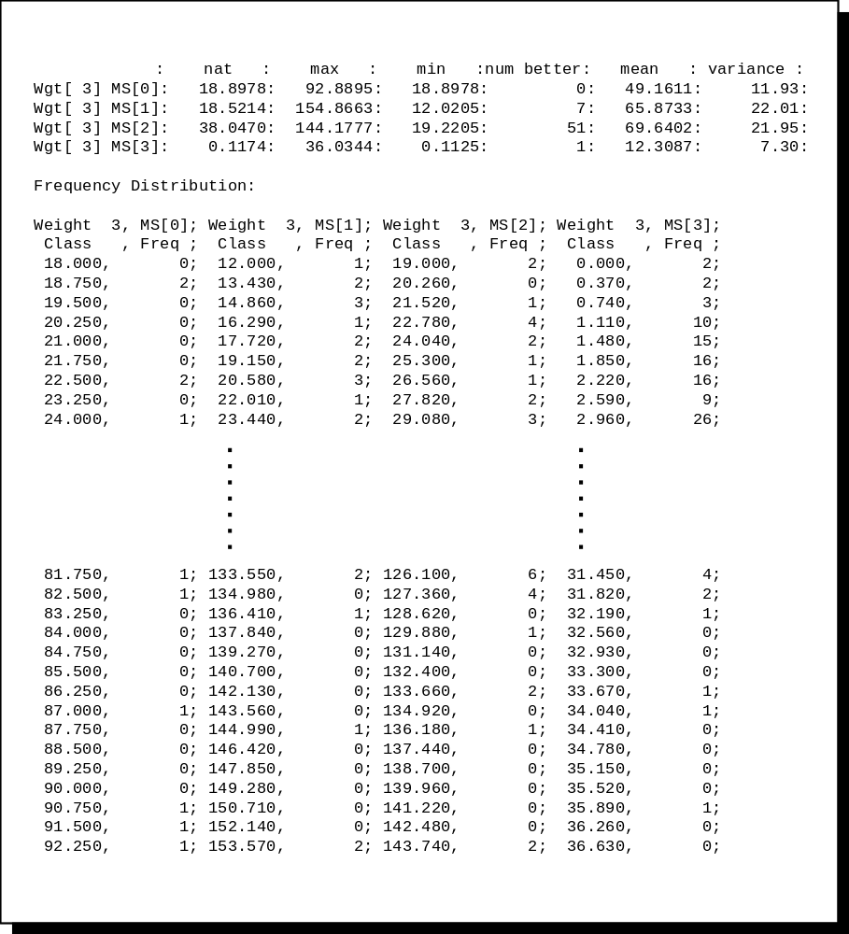
Figure 1f: The second section of the ASCII results file for a single sample analysis: summary statistics and frequency distribution

(either modular difference in Polar Requirement or the appropriate transformed PAM matrix score).
The structure of the second half of the results file will vary according to the type of analysis undertaken. If the analysis type was Produce Single Sample, then two tables will be produced (figure 1f). The first summarises the code error values of the initial code structure, the maximum and minimum error values encountered in the sample, the number of better code structures found within the sample and the mean and variance of the sample. The second is a straightforward frequency distribution for the sample at each base position, divided into 100 classes of error value. If the analysis undertaken was Produce Many Samples, then the second half of the results file will contain 20 tables (figure 1g): 5 measures pertaining to the sample for each of the 4 base positions (base positions
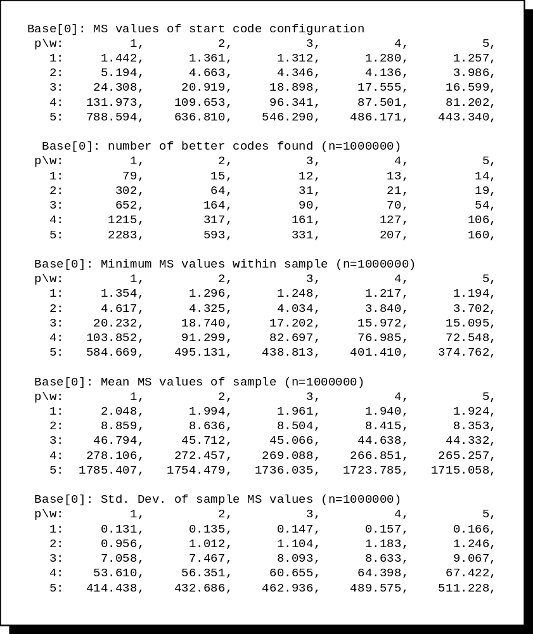
Figure 1g: The second section of the ASCII results file for a multi-sample analysis: the 5 tables pertaining to base[0] (i.e. all bases combined: see chapter 3). In a genuine results file, another 15 tables would be found, detailing the same 5 metrics for each of the 3 individual base positions.

1 to 3 and all base positions combined). The five measures are: code error values of the starting code; the number of better codes found; the minimum and maximum error values found within the sample; and the mean and standard deviation of the sample. Each table is composed of the appropriate values for each point in parameter space specified prior to the analysis (i.e. each transition bias and modular power function in the range specified by the user).
Finally, if the analysis undertaken was Optimize Code Structure, then the second half of the results file will comprise a single table (figure 1h) showing the error value for the initial code configuration, and for the best code configuration found after repeated application of the Great Deluge Algorithm (GDA). Once again, the size of the table ill depend on the range of transition biases and modular power functions specified by the user prior to the analysis.
Any and all results files maybe opened in word-processors, spreadsheets or graph packages
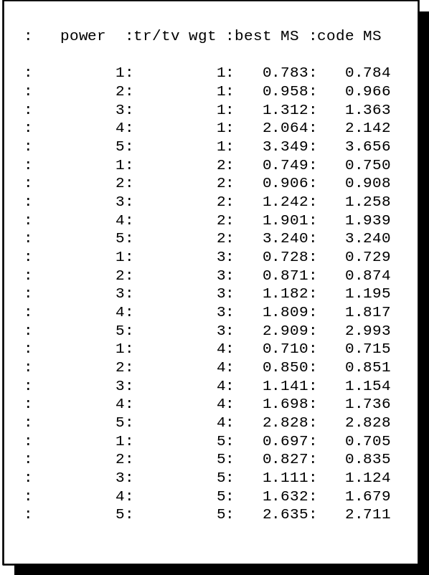
Figure 1h The second section of the ASCII results file for an Optimize Code Structure analysis: the single table shows the error value of the initial code and that of the best code found at each point in parameter space.

capable of recognising ASCII text. The work presented in this thesis used Micrsoft Excel©, which has particularly advanced parsing capabilities. The user is able to specify the characters used to discriminate different entries (in this case commas and colons), and then to manipulate data and plot the graphs presented throughout this thesis.

2.3 Changing amino acid parameters
In its current form, the program only recognises two data files defining measures of amino acid similarity. The first (detailing amino acid Polar Requirement) is specified by file "a_acid_f.txt" (see section 1.3 of this appendix), the second (PAM 74-100 matrix data) is specified by file "PAM74100.txt". By default, the program reads in Polar Requirement values, but either file may be read by the program if the user changes measures of amino acid similarity (see section 2.1b). Neither file is of a complex format (figure 1i), and it is relatively easy for the user to change one or all values contained therein. For example, if the user wished to investigate code structure in terms of a different physiochemical property, this could be achieved by opening file "a_acid_f.txt" and altering the values appropriately. Likewise, data from a different PAM matrix may be substituted into file "PAM74100.txt".
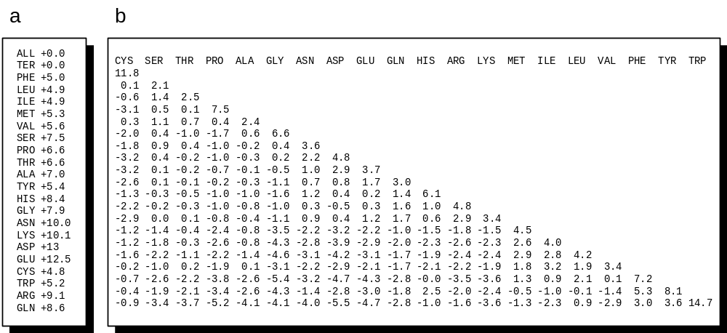
Figure 1i Structure of the two auxiliary data files specifying amino acid similarity: (a) file "a_acid_f.txt" contains the (capitalised) 3 letter abbreviations of the 20 amino acids with appropriate Polar Requirement values, together with dummy values for 'Ter' and 'All'; (b) file "PAM74100.txt" contains the (capitalised) 3 letter abbreviations of the 20 amino acids with the traditional 'half-PAM-matrix'.

There are two major restrictions. First, file "a_acid.txt" must contain (in addition to the names and values for the 20 amino acids) the names 'Ter' and 'All', with associated values. The program ignores changes to and from 'Ter' codons, so the value is immaterial in this sense, but both identities and values must be present for the proper functioning of the program. Second, file "PAM64100.txt" must only contain amino acid identities in a horizontal row along the top: the program assumes that the vertical ordering is the same as the horizontal ordering. Adjusting the values contained within these two files enables the user to explore code structure for any measure of amino acid similarity.

2.4 File creation
During analysis, the program will create the ASCII results file described above (section 2.3), which will occupy between 1K and 15K, depending on the analysis undertaken. For example, if the user chooses to Produce Many Samples (section 2.1b), then the size of the results file will reflect the parameter ranges selected. If the user chooses analysis type Produce Single Sample (section 2.1b), this implies production of an associated frequency distribution. In order to produce this frequency distribution, during run-time, the program will produce a temporary binary file using ANSI 'C' command 'tmpfile') which stores the error value of each code generated within the sample. The error value for each code in the sample requires 8 bytes of memory, thus a sample of 1 million codes will produce a file of almost 8 mega-bytes. The location of this file is compiler dependent.

3 Internal Documentation
The program source code contains comprehensive annotations to describe details of the program's workings. This section aims to provide a brief overview to provide a conceptual backdrop against which these comments should be clear.

3.1 Fundamental data structures
Fundamentally, the program revolves around 3 data structures: the codon matrix ('codon_matrix'), the amino acid array ('acid_array'), and an irregular data structure with many different fields ('settings'). All three key variables are passed through the program as pointers to optimize program speed. The first two variable are straightforward: 'codon_matrix' is a 4x4x4 matrix of values (type short) which represents a particular genetic code. Each element of the matrix implies a codon simply through its coordinates, thus codon_matrix[0][0][0] implies codon UUU, and codon_matrix[3][3][3] implies GGG. The value held by each element indicates its amino acid assignment in terms of the (amino) acid_array. This array is 22 elements long, beginning with a dummy element, and ending with the meaning 'Ter' (these dummy elements allow safe shuffling of meanings and elements elsewhere in the program). Each of the 22 elements of the array is divided into 2 fields, 'name' and 'parameter'. The field 'name' carries the 3 letter abbreviation of the amino acid implied by that element (i.e. acid_array[21].name carries the value "TER"). The field parameter carries a value indicating the identity of that amino acid in a further invariant matrix of values representing the magnitudes of error implied by each possible genetic error, from one amino acid to another. This final matrix is carried as one of the fields of settings. This information is summarised in figure 1j.
The importance of this arrangement is that both the amino acid array and the codon matrix are free to vary, with different implications, whilst the error matrix (a 20x20 matrix of floating point values), once calculated, remains invariant. Thus, for example, when an analysis is underway a variant code can be produced simply by swapping the 20 central elements of the amino acid array: there is no need to alter all 64 elements of the codon matrix, or to re-calculate the 'difference' scores. This arrangement therefore maximises program speed.
Most of the other fields of settings are hold user defined values of the parameters to be used in a particular analysis, and values of particular results parameters (e.g. a matrix of elements for the number of better codes found at a variety of different parameter settings).

3.2 Program structure
The fundamental structure of the program is summarised in figure 1.10, and occurs in 3 stages. First the program undertakes sets up enough information for a basic analysis run: the default settings. this requires reading in a set of amino acid parameters, a genetic code structure, calculation of the error magnitudes associated with each possible change between two amino acids, and linking the 3 fundamental data structures (figure 1.9). This stage is supervised by function "Initial_Set_Up".

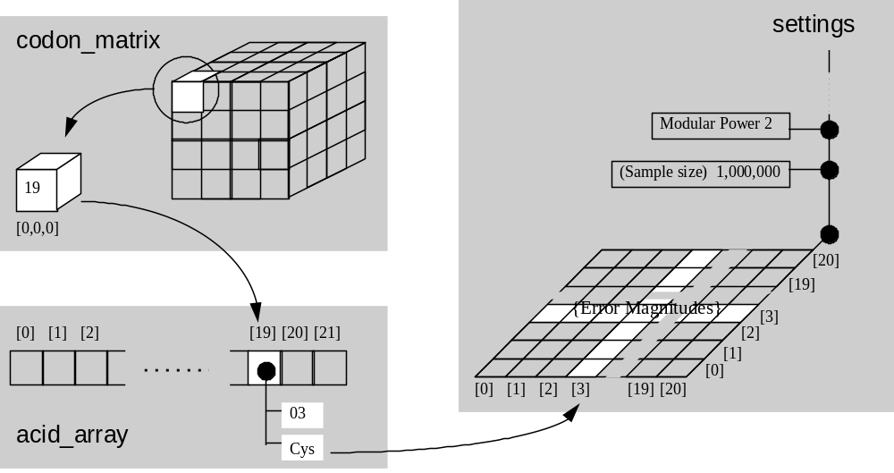
Figure 1j The arrangement and interdependency of the three key program variables: a single codon (e.g. [0][0][0] = UUU) implies an element of the amino acid array (e.g. Cys) which in turn points to a row/column of the invariant matrix of 'difference' scores representing the magnitude of error of a particular substitution.

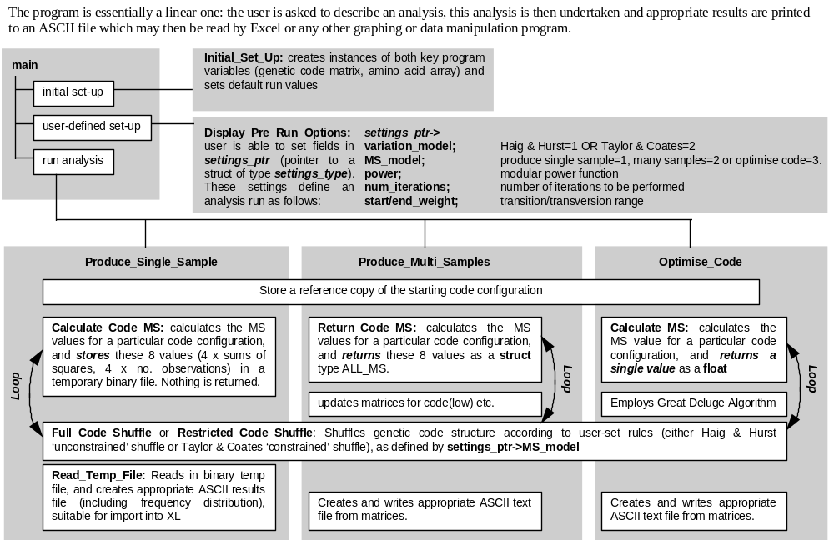
Figure 1k Overview of program gen_code.exe. See accompanying text for a broad description. Detailed documentation is found within the program in the form of comprehensive comments.

Second, the program enters a loop, centred around the display of current parameter settings (described in terms of output in section 2: 'External Documentation'). This is supervised by function "User_Defined_Set_Up". The loop continues until the user elects to start an analysis.
Finally, the program uses the current parameter settings to undertake an analysis of code structure. Analysis is handled by one of 3 major functions: "Produce_Single_Sample", "Produce_Multi_Samples" and "Optimise_Code", depending on the type of analysis undertaken. Much of three routines is similar: all call the same codon-assignment shuffling routines, calculate code error in the same way etc: the split simply optimises speed (avoiding large numbers of conditional statements etc.). A brief guide to the similarities and differences between functions is shown in figure 1k. At the end of analysis, the results file is written and the program terminates.

3.3 Source code overview
The source code of the program is divided into 16 files: files are organised to meet a specific set of needs, described in notes at the start of the file. Full source code is provided on in section 3.4. The following quick reference to file contents may be useful when exploring the program code:

filename functions
main.c: void main()
codons.h: (header file: contains definitions of custom data types. These are always all captialized)
gen_io.c: FILE* Safe_Open(char* , char* , int)
char Get_Character(char, char)
void Pause(void)
void Print_Break(void)
long Read_Integer(FILE*)
long Get_User_Input_Number(long , long)
void Display_Directory_Contents(void)
FILE* List_Files(char*)

random.c float URandom(void)
int Random_Int (int, int)

parse.c void Transform_PAM_Matrix(SETTINGS_TYPE*)
short Is_Codon(char )
void Base_to_Range(char, short*, short* )
short Is_Acid(char[3], ACID_ELEMENT_TYPE*)
char Number_to_Base(int)
int Base_to_Number(char)
int Acid_to_Number(NAME, ACID_ELEMENT_TYPE* )
short Is_Transition(COORD, COORD, short)
short Is_A(COORD, short)

in_out.c void Print_Codon_Matrix(FILE*, MATRIX_TYPE*, ACID_ELEMENT_TYPE* )
void Print_Acid_Array(FILE*, ACID_ELEMENT_TYPE*)
void Print_Mutant_Matrix(MATRIX_TYPE*, ACID_ELEMENT_TYPE*, SETTINGS_TYPE*)
void Read_Acid_Parameters(SETTINGS_TYPE*, ACID_ELEMENT_TYPE*, char* )
void Read_PAM_Matrix(SETTINGS_TYPE*, ACID_ELEMENT_TYPE*, char*)
filename functions

void Print_PAM_Matrix(SETTINGS_TYPE*, ACID_ELEMENT_TYPE*, FILE*)
void Read_Codon_Matrix(MATRIX_TYPE*, FILE*, ACID_ELEMENT_TYPE*)
void Store_MS_Values(SETTINGS_TYPE*, FILE*, ALL_MS)
void Print_MS_Matrix(MS_STRUCT**, FILE*, short, short, long)

mut_calc.c short Check_Legitimacy(COORD, COORD, MATRIX_TYPE*, ACID_ELEMENT_TYPE*)
MUTANT Load_Mutant(int*, COORD, COORD, short)
int Count_Mutants(ACID_ELEMENT_TYPE*, MATRIX_TYPE*)
void Load_Mutant_Array(MATRIX_TYPE*, ACID_ELEMENT_TYPE*, MUTANT*, COORD, int*)
void Build_Mutant_Array(SETTINGS_TYPE*, ACID_ELEMENT_TYPE*, MATRIX_TYPE*)

setup.c void Set_Acid_String(ACID_ELEMENT_TYPE*)
void Initial_Set_Up(MATRIX_TYPE*, ACID_ELEMENT_TYPE*, SETTINGS_TYPE*)

setting.c void Print_MS_Model_String(FILE*, SETTINGS_TYPE*)
void Print_Variation_Model_String(FILE*, SETTINGS_TYPE*)
void Print_Similarity_Measure(FILE*, SETTINGS_TYPE*)
void Print_Results_Model_String(FILE*, SETTINGS_TYPE*)
void Change_Results_Model(SETTINGS_TYPE*, MATRIX_TYPE*, ACID_ELEMENT_TYPE* )
void Change_Similarity_Measure(SETTINGS_TYPE*, ACID_ELEMENT_TYPE*)
void Change_Variation_Model(SETTINGS_TYPE*, MATRIX_TYPE*, ACID_ELEMENT_TYPE*)
void Change_Iterations(SETTINGS_TYPE*)
void Change_Weightings(SETTINGS_TYPE*)
void Change_MS_Model(SETTINGS_TYPE*)
void Choose_Code(MATRIX_TYPE*, ACID_ELEMENT_TYPE*, SETTINGS_TYPE*)
void Save_Code(MATRIX_TYPE*, ACID_ELEMENT_TYPE*, SETTINGS_TYPE*)
void Reassign_Codons(MATRIX_TYPE*, ACID_ELEMENT_TYPE*)
void Change_Code(SETTINGS_TYPE*, MATRIX_TYPE*, ACID_ELEMENT_TYPE*)
void Change_Modular_Power_Function(SETTINGS_TYPE*)
void Display_Pre_Run_Options(MATRIX_TYPE*,ACID_ELEMENT_TYPE*, SETTINGS_TYPE*)

ms_calc.c ALL_MS Clear_All_MS(void)
float Find_tMS_Weighting(MUTANT)
float Find_Weighting(short, short, MUTANT)

factoria.c int Factorial (short)
INT_LIST_ELEMENT* Make_Linked_List(short)
void Find_Permutation(short, int, short*)

shuffle.c void Full_Code_Shuffle(ACID_ELEMENT_TYPE*)
void Restricted_Code_Shuffle(ACID_ELEMENT_TYPE*)

analyse.c void Print_Results_Header(SETTINGS_TYPE*, MATRIX_TYPE* , ACID_ELEMENT_TYPE*)
void Print_Results(SETTINGS_TYPE*,RESULTS_STRUCT)
void Fill_Freq_Arrays(SETTINGS_TYPE*, RESULTS_STRUCT, FREQ_ARRAY*)
void Frequency_Distribution(SETTINGS_TYPE*, RESULTS_STRUCT)
void Read_Temp_File(SETTINGS_TYPE*, MATRIX_TYPE*, ACID_ELEMENT_TYPE*)

1_sample.c void Calculate_Code_MS(MATRIX_TYPE*, ACID_ELEMENT_TYPE*, SETTINGS_TYPE*)
void Produce_Single_Sample(void, MATRIX_TYPE*,ACID_ELEMENT_TYPE*, SETTINGS_TYPE*)

n_samples.c void Store_Nat_MS(MS_STRUCT**, short, short)
void Update_MS_Matrix
(SETTINGS_TYPE*,MATRIX_TYPE*,ACID_ELEMENT_TYPE*, MS_STRUCT**)
void Produce_Multi_Samples(void, MATRIX_TYPE*, ACID_ELEMENT_TYPE*, SETTINGS_TYPE*)

optimize.c float Calculate_MS(MATRIX_TYPE*, ACID_ELEMENT_TYPE*, SETTINGS_TYPE*, short, shortt)
void Local_Peturb(SETTINGS_TYPE*, short*, short*)
void Optimise_Code(void, MATRIX_TYPE*, ACID_ELEMENT_TYPE*, SETTINGS_TYPE*)

3.4 Source Code

main.c: the central function of the program

# define TRUE 1
# define FALSE 0
#define MAX_ITERATIONS 2000000

#include <stdio.h>
#include <string.h>
#include <ctype.h>
#include <math.h>
#include <stdlib.h>

#include "codons.h"
#include "gen_io.c"
#include "random.c"
#include "parse.c"
#include "in_out.c"
#include "mut_calc.c"
#include "setup.c"
#include "setting.c"
#include "ms_calc.c"
#include "factoria.c"
#include "shuffle.c"
#include "analyse.c"
#include "1_sample.c"
#include "n_samples.c"
#include "optimize.c"

void main()
{
SETTINGS_TYPE settings; /* the three fundamental data structures */
MATRIX_TYPE codon_matrix;
ACID_ARRAY acid_array;

Initial_Set_Up(&codon_matrix, acid_array, &settings); /* Loads defaults */

Display_Pre_Run_Options(&codon_matrix, acid_array, &settings); /* allows user manipulationof parameters */

Build_Mutant_Array(&settings, acid_array, &codon_matrix); /* calculates all errors possible within the code under consideration */

switch(settings.results_model) /* Executes a particular type of analysis */
{
case 1: if(settings.variation_model == 1) Produce_Single_Sample (Full_Code_Shuffle, &codon_matrix, acid_array, &settings);
else Produce_Single_Sample(Restricted_Code_Shuffle, &codon_matrix, acid_array, &settings); break;
case 2: if(settings.variation_model == 1) Produce_Multi_Samples(Full_Code_Shuffle, &codon_matrix, acid_array, &settings);
else Produce_Multi_Samples(Restricted_Code_Shuffle, &codon_matrix, acid_array, &settings); break;
case 3: if(settings.variation_model == 1) Optimise_Code(Full_Code_Shuffle, &codon_matrix, acid_array, &settings);
else Optimise_Code(Restricted_Code_Shuffle, &codon_matrix, acid_array, &settings); break;
default: printf("\n ERROR in 'main.c': I don't know what to do!"); Pause(); break;
}

printf("\n Analysis Complete: review contents of RESULTS.TXT");
Pause();
}

codon.h: header file containing data type defiitions

/* Useful for storing 3 letter strings: amino acid names and codons*/
typedef char NAME[4];

/* The fundamental unit of the amino acid array */
struct Acid_Struct
{
NAME name;
float parameter;
};
typedef struct Acid_Struct ACID_ELEMENT_TYPE;
typedef ACID_ELEMENT_TYPE ACID_ARRAY[22];

/* COORD is a handy little number for moving through the matrix */
struct Coordinate
{
short x;
short y;
short z;
};
typedef struct Coordinate COORD;

/* The following compound structure stores data necessary to calculate MS */
/* values for any given codon: the structure looks like this: */
/* */
/* {ALL_MS} variable.MS[n].num_obs {INT} */
/* .total_SS {FLOAT} */
/* */
/* where n = 0..3 */
/* */

struct Single_MS /* contains two fields: one for the total sum of squares */
/* (total_SS), and one for the number of observations (num_obs) */
{
float num_obs;
float total_SS;
};
typedef struct Single_MS SINGLE_MS;

struct All_MS /* Stores all MS measurements for a particular amino acid */
{
SINGLE_MS MS[4];
};
typedef struct All_MS ALL_MS;

/* type MUTANT contains all information pertaining to a particular point mutation */
/* */
/* .stt_coord [a struct of type COORD which collectively describes */
/* the codon in MATRIX_TYPE from which a that particular */
/* point mutation has occurred] */
/* mutation represents a transition mutation] */
/* .mut_coord [a struct of type COORD which collectively describes */
/* the new codon in MATRIX_TYPE which that particular */
/* point mutation would lead to] */
/* mutation represents a transition mutation] */
/* .is_transition [a 0 or 1 value indicating whether that partiular */
/* mutation represents a transition mutation] */
/* .base_number [a 0..3 value indicating which codon base number that */
/* mutation represents] */
/* .is_A [a 0 or 1 value indicating whether that particular */
/* mutation represents a mutation N->A] */
/* */
struct Mutant_Element
{
short is_transition;
short base_number;
short is_A ;
COORD mut_coord;
COORD stt_coord;
};

typedef struct Mutant_Element MUTANT;

/* THE CODON MATRIX: the basic 4x4x4 matrix, each element referring to one of the 64 codons, */
/* and contains a SHORT indentifier to indicate which amino acid that element refers to */
/* (i.e.a number <22) referring to an element of the amino acid array "acid_array" */
struct matrix_element
{
short acid_number;
};
typedef struct matrix_element MATRIX_ELEMENT;
typedef MATRIX_ELEMENT MATRIX_TYPE[4][4][4];

/* A data structure used to create linked lists of integers: used in code shuffling routines */
struct Int_List_Element
{
short number;
struct Int_List_Element* next_element;
struct Int_List_Element* last_element;
};
typedef struct Int_List_Element INT_LIST_ELEMENT;

/* MS struct contains fields for the data pertaining to a a sample's error values */
struct MS_Struct
{
long num_bt[4];
float num_obs[4];
float tot_SS[4];
float min_MS[4];
double nat_MS[4];
double tot_MS[4];
double tsq_MS[4];
};
typedef struct MS_Struct MS_STRUCT;

/* Results struct is used in creating a frequency array from a data file */
/* of individual error values for a sample */
struct Results_Struct
{
MS_STRUCT MS;
float max_MS[4];
float min_MS[4];
float interval[4];
};
typedef struct Results_Struct RESULTS_STRUCT;

/* contains fields for a frequency distribution of 100 classes for */
/* 4 error value types: each base position and all bases combined */
struct Freq_Array
{
long freq[4][100];
};
typedef struct Freq_Array FREQ_ARRAY;

struct Settings_Struct /* stores details describing a particular simulation run */
{
long num_iterations; /* number of members to produce in a sample */
short start_weight; /* lower limit of Tr/Tv weighting (w)*/
short end_weight; /* upper limit of Tr/Tv weighting (w)*/
short MS_model; /* Tr/Tv, n->A, OR mistranslation */
short variation_model; /* Haig and Hurst or Taylor and Coates */
short results_model; /* produce a sample or optimise */
short similarity_measure; /* PAM matrix or Physiochemcial Properties: method by which amino acid similarity is measured */
short trap_codes; /* create results file of better code structures? */
short power; /* modular power function (p) can be used as a range upper limit, or a single value*/
int num_mutants; /* the number of legitimate mutations in a particular code (<9*64) */
float** PAM_matrix; /* a pointer to the matrix of modular error values for a particular amino acid substitution */
MUTANT* mutant_array; /* an array of all the possible mutations in a particular code */
FILE* results_file_ptr; /* a pointer to the ASCII results file */
FILE* tmp_file_ptr; /* a pointer to the temporary (binary) file used to store individual error values for a sample */
};
typedef struct Settings_Struct SETTINGS_TYPE;

gen_io.c: general input and output routines (NOT program specific)

/* File "gen_io.c" conatains source code for general input/output*/
/* functions handling reading types of user input, safe opening */
/* of data streams and the most general types of output */
/* Functions in here are DELIBERATELY NOT PROGRAM SPECIFIC */

/* A general function for the Safe opening of file streams: */
/* accepts a string detailing the file to be opened, a string */
/* detailing the type of opening (reading, writing etc.) and a */
/* indicating whether the output stream should detail what is being */
/* attempted. If the opening is unsuccessful, the function warns */
/* the user and prompts for an alternative path string. */
/* The function is safe in that it will not finish until a file has*/
/* successfully been opened. */
FILE* Safe_Open(char* file_string, char* action_string, int warn)
{
FILE* file_ptr;

file_ptr = (fopen(file_string, action_string));

if ((file_ptr!=NULL) && (warn==TRUE))
{
printf("\n\n '%s' File Opened Successfully For ", file_string);
if (action_string[0]=='r') printf("Reading!");
if (action_string[0]=='w') printf("Writing");
}

while (file_ptr==NULL)
{
printf("\n\n '%s' File Could Not Be Opened!", file_string);
printf("\nPlease enter an alternative:");
gets(file_string);
file_ptr = (fopen(file_string, action_string));
}

return file_ptr;
}

/* Function Get_Character gets a single character user input */
/* (from the stdin stream) which lies in a requested interval. */
/* If the user input does not lie in the requested interval */
/* the the user is prompted for a new input, with permissable */
/* interval indicated. The function does not finish until a */
/* suitable character has been typed in */
char Get_Character(char lower, char upper)
{
char command[80], buffer;
fgets(command, 80, stdin);
buffer=command[0];

while ((buffer<lower)||(buffer>upper))
{
printf("\n %cINVALID ENTRY!\n Command?", 7);
fgets(command, 80, stdin);
buffer=command[0];
}
return buffer;
}

/* Function Pause simply prevents further progress in the */
/* program until the user has typed the 'return' key */
void Pause(void)
{
char buffer;
buffer = Get_Character(0, 127);
}

void Print_Break(void)
{
printf("\n**********************************************************************");
}

/* safely reads an integer from a file specified by 'file_ptr', and returns as the arugment of */
/* the function. accepts '+ and '-' as prefixes, and ignores (reads through) other non-digit characters */
long Read_Integer(FILE* file_ptr)
{
int valid = FALSE;
long integer=0, multiplier;
char buffer='\0';
multiplier = 1;

while(((buffer<'0') || (buffer>'9')) && (feof(file_ptr)==FALSE))
{
buffer = fgetc(file_ptr);
if(buffer == '-') multiplier = -1;
if(buffer == '+') multiplier = +1;
}

while(((buffer>='0') && (buffer<='9')) && (!feof(file_ptr)))
{
valid = TRUE;
integer = (integer*10) + (buffer - '0');
buffer = fgetc(file_ptr);
valid = FALSE;
}
return integer;
}

/* Function Get-User_Input accepts two arguments (both LONG), which define the */
/* minimum and maximum acceptable integer inputs. It reads a user entry, and */
/* either accepts and returns this entry, or sounds a warning, specifies the */
/* appropriate range and then reads in another number */
long Get_User_Input_Number(long min, long max)
{
long entry_num;

entry_num = (long) Read_Integer(stdin);

while((entry_num<min)||(entry_num>max))
{
printf("\n %cINVALID ENTRY: please reenter a value between %ld and %ld:", 7, min, max);
entry_num = (short) Read_Integer(stdin);
}
return entry_num;
}

/* The following functions are DOS specific functions which link */
/* the application to a range of basic OS commands */
void Display_Directory_Contents(void)
{
system(" dir /p");
Pause();
}

/* Function 'List_Files' list all files inthe current working directory which conform to a particular */
/* file extension(S) (specified by the string 'extension'). These are initally listed to a text file */
/* (file system_text = 'system.txt'), and are then printed to stdout, with an associated number for */
/* each file. The user is then asked to identify the file of interest by entering the associated */
/* number, and this file is safely opened (for reading) and returned as the argment of the function */
/* This function is the only system dependent code in the program, and should be modified by users */
/* not working in an MS-DOS environment. In particular, it makes use of the 'system' command to send */
/* a comand line instruction to the operating system. THIS INSTRUCTION IS MS-Dos SPECIFIC */
FILE* List_Files(char* extension)
{
char system_command[100], buffer;
short counter, start=0, valid = TRUE;
FILE* system_text;

system_text = Safe_Open("system.txt\0", "w\0", FALSE); /* creates an empty text file to contain the results of the OS iinstructions */
fclose(system_text); /* ensures accessibility for the OS instructions */
strcpy(system_command, " dir *.*** >> system.txt /b \0");/* text instruction to the OS to list all files, placing results in a test file called 'system.txt' */
while(valid) /* loops through all file extensions passed in string 'extension', appending file 'system.txt' with the results of "dir [extension]" */
{
for(counter = 0; counter<5; counter +=1) /* replaces the 5 characters *.*** with an extension specified in 'extension' */
{
buffer = extension[counter+(6*start)];
system_command[5+counter]=buffer;
}
system(system_command); /* executes the system command */
buffer = extension[5+start];
start +=1;
if(buffer!=',') valid = FALSE; /* 'extension' is a comma delimited list of file extensions */
}

system_text = Safe_Open("system.txt\0", "r\0", FALSE); /* opens 'system.txt' to read the filenames stored there */
valid = TRUE; counter = 0; buffer = '\n'; /* sets variables ready for the following routine */

while(valid) /* this routine prints all 'dir' files to the screen as a numbered list */
if(buffer=='\n')
{
buffer = fgetc(system_text);
if(feof(system_text)) valid = FALSE;
else
{
counter +=1;
printf("\n %2hd: ", counter);
}
printf("%c", buffer); buffer = fgetc(system_text);
}
else
{ printf("%c", buffer); buffer = fgetc(system_text); }

printf("\n ----------\n File for Input (1..%hd)?", counter);
counter = (short)Get_User_Input_Number(1, counter); /* Requests listed number of file to opened */

rewind(system_text);
for(start=0; start<counter; start+=1)
fgets(system_command, 50, system_text);

system_command[strlen(system_command)-1]='\0';

fclose(system_text);
system("del system.txt");
system_text = Safe_Open(system_command, "r\0", TRUE);

return system_text;
}
random.c: psuedo-random number generator

/* Taken from 'Numerical recipes in C', this is given as 'ran1', page 280*/
/* and passes all statistical tests for randomness until called approx */
/* 10^8 times */

#define IA 16807
#define IM 2147483647
#define AM (1.0/IM)
#define IQ 127773
#define IR 2836
#define NTAB 32
#define NDIV (1+(IM-1)/NTAB)
#define EPS 1.2e-7
#define RNMX (1.0-EPS)

long idum = -317;

float URandom(void)
/* Produces a random number between 0 and 1; call with 'idum', a negative no. */
{
int j;
long k;
static long iy=0;
static long iv[NTAB];
float temp;

if(idum <=0 || !iy) /* Initialise */
{
if (-(idum) < 1) idum = 1; /* Be sure to prevent idum = 0 */
else idum = -(idum);
for (j=NTAB+7; j>=0; j--)
{
k=(idum)/IQ;
idum= IA*(idum-k*IQ)-IR*k;
if (idum < 0) idum += IM;
if (j < NTAB) iv[j] = idum;
}
iy = iv[0];
}

k = (idum)/IQ;
idum=IA*(idum-k*IQ)-IR*k; /* Starts here when not intialising */
if (idum < 0) idum += IM;
j = iy/NDIV;
iy = iv[j];
iv[j] = idum;
if ((temp=(float)AM*iy) > RNMX) return (float) RNMX;
else return temp;
}

int Random_Int (int min, int max)
/* Calls URandom to get a random real number between 0 and 1, */
/* and turns this into an integer between 'min' and 'max' */
{
float num, temp;
int return_value, interval;

interval = max - min;

num = URandom();

temp = (num*interval)+min;

return_value = (int)(temp+0.5);

return return_value;
}

parse.c: functions to recognise and convert nucelotides to numbers

/* Function Transform_PAM_Matrix transforms PAM matrix values according to Ardell, 1998 */
void Transform_PAM_Matrix(SETTINGS_TYPE* settings_ptr)
{
short counter, count2;
float value;
for(counter=0; counter<20; counter+=1)
for(count2=0; count2<20; count2+=1)
{
value = settings_ptr->PAM_matrix[counter][count2];
settings_ptr->PAM_matrix[counter][count2] = (float)pow(10, (value/10)*-1);
}
for(counter=0; counter<20; counter+=1)
settings_ptr->PAM_matrix[counter][counter] = 0;
}

/* Function Is_Codon finds whether a character may be interpreted as a nucleotide (returns 1) or not (returns 0) */
short Is_Codon(char codon[3])
{
short base, valid = TRUE;
for(base = 0; base<3; base+=1)
{
codon[base] = toupper(codon[base]);
switch(codon[base])
{
case 'U': break;
case 'C': break;
case 'A': break;
case 'G': break;
case 'N': break;
case 'R': break;
case 'Y': break;
default: valid = FALSE; break;
};
}
return valid;
}

/* Accepts any nucleotide notation, and returns a range of values between 0 and 4, representing */
/* the nculeotides indicated by this notation e.g. R=A or G, this corresponds to the range 2..3 */
void Base_to_Range(char base, short* lower_ptr, short* upper_ptr)
{
base = toupper(base);
switch(base)
{
case 'U': *lower_ptr =0; *upper_ptr =0; break;
case 'C': *lower_ptr =1; *upper_ptr =1; break;
case 'A': *lower_ptr =2; *upper_ptr =2; break;
case 'G': *lower_ptr =3; *upper_ptr =3; break;
case 'N': *lower_ptr =0; *upper_ptr =3; break;
case 'R': *lower_ptr =2; *upper_ptr =3; break;
case 'Y': *lower_ptr =0; *upper_ptr =1; break;
default: break;
};
}

/* Function Is_Acid compares a 3 character string ('name') with the 'name' fields held in the */
/* amino acid arra. I f a match is found, then the function returns 1; if no match, 0 is returned */
short Is_Acid(char name[3], ACID_ELEMENT_TYPE* acid_array)
{
short count, valid = FALSE;
for(count = 0; count<3; count+=1)
name[count] = toupper(name[count]);
for(count = 0; count<22; count+=1)
if(strcmp(name, acid_array[count].name)==0) valid = TRUE;
return valid;
}

/* Converts a numb er(0..3) to the corresponding nucleotide character. Useful for converting coordinates to codons */
char Number_to_Base(int number)
{
char base;
switch (number)
{
case 0: base = 'U'; break;
case 1: base = 'C'; break;
case 2: base = 'A'; break;
case 3: base = 'G'; break;
default: base = '*'; break;
}
return base;
}

/* converts a nucleotide character to the appropriate number (0..3). useful for converting codons to coordinates */
int Base_to_Number(char base)
{
int number;
switch (base)
{
case 'U': number = 0; break;
case 'C': number = 1; break;
case 'A': number = 2; break;
case 'G': number = 3; break;
default: number=99; break;
}
return number;
}

/* Converts an amino acid name (3 characters) to the appropriate number as found in the amino acid array */
int Acid_to_Number(NAME acid_name, ACID_ELEMENT_TYPE* acid_array)
{
unsigned short int counter=0, acid_number = 0;
while ((acid_number == 0) && (counter<22))
{
counter++;
if(strcmp(acid_name, acid_array[counter].name)==0) acid_number = counter;
}
return acid_number;
}

/* Takes two coordinates (e.g. a the codons involved in a genetic error and compares them to
/* identify whether the change implied corresponds to a transition (function returns 1) or a transversion (returns 0) */
short Is_Transition(COORD start_coord, COORD this_coord, short base_num)
{
short transition = FALSE;
short base1_num , base2_num;
char base1_char, base2_char;
switch (base_num)
{
case 1: base1_num = start_coord.x; base2_num = this_coord.x; break;
case 2: base1_num = start_coord.y; base2_num = this_coord.y; break;
case 3: base1_num = start_coord.z; base2_num = this_coord.z; break;
}
base1_char = Number_to_Base(base1_num);
base2_char = Number_to_Base(base2_num);
if((base1_char == 'A') && (base2_char == 'G')) transition = TRUE;
if((base1_char == 'G') && (base2_char == 'A')) transition = TRUE;
if((base1_char == 'C') && (base2_char == 'U')) transition = TRUE;
if((base1_char == 'U') && (base2_char == 'C')) transition = TRUE;
return transition;
}

/* identifies whether a particular genetic error is to 'A' or 'U'. Used by the weighting model N->A */
short Is_A(COORD this_coord, short base_num)
{
short is_A = FALSE;
short base1_num;
char base1_char;
switch (base_num)
{
case 1: base1_num = this_coord.x; break;
case 2: base1_num = this_coord.y; break;
case 3: base1_num = this_coord.z; break;
}
base1_char = Number_to_Base(base1_num);
if((base1_char == 'A')||(base1_char == 'U')) is_A = TRUE;
return is_A;
}
in_out.c: program-specific input/output functions

/* File "in_out.c" contains source code for PROGRAM SPECIFIC */
/* input/output functions: output of data structures (the codon */
/* matrix, mutant matrix and amino acid array); reading in of */
/* particular data files (amino acid parameter files, genetic code files) etc. */

/* Function Print_Codon_Matrix prints the contents of the codon */
/* matrix to a file specified by a pointer passed as an argument */
/* to the function. The matrix is printed as each of the codons */
/* (in the form of nucleotide labels), and the current associated meaning */
void Print_Codon_Matrix(FILE* file_ptr, MATRIX_TYPE* codon_matrix_ptr, ACID_ELEMENT_TYPE* acid_array)
{
char char1, char2, char3;
COORD coord;
NAME this_name;

for(coord.x=0; coord.x<4; coord.x+=1)
{
fprintf(file_ptr, "\n");
for (coord.z=0; coord.z<4; coord.z+=1)
{
fprintf(file_ptr, "\n");
for (coord.y=0; coord.y<4; coord.y+=1)
{
char1 = Number_to_Base(coord.x);
char2 = Number_to_Base(coord.y);
char3 = Number_to_Base(coord.z);
strcpy (this_name, acid_array[(*codon_matrix_ptr)[coord.x][coord.y][coord.z].acid_number].name);
fprintf(file_ptr, " %c%c%c:%c%c%c", char1, char2, char3, tolower(this_name[0]), tolower(this_name[1]), tolower(this_name[2]));
}
}
}
}

/* Function Print_Acid_Array prints the 22 elements of the amino acid array to a file specified by a pointer passed */
/* as an argument to the function. Each amino acid (plus TER and ALL) are printed with their current associated parameter values */
void Print_Acid_Array(FILE* file_ptr, ACID_ELEMENT_TYPE* acid_array)
{
short counter[2];

for(counter[0] = 0; counter[0]<7; counter[0]+=1)
{
fprintf(file_ptr, "\n");
for(counter[1]=1; counter[1]<4; counter[1]+=1)
fprintf(file_ptr, " %3s: %5.2f ", acid_array[counter[1]+(3*counter[0])].name, acid_array[counter[1]+(3*counter[0])].parameter);
}
}

/* Function Read_Acid_Parameters takes a path for a text file (containing the 3 letter abbrevations of each amino acid, */
/* together with a numerical value for each) and reads in the file, matching parameter values to the amino acid names */
/* already stored in amino_acid_array */
void Read_Acid_Parameters(SETTINGS_TYPE* settings_ptr, ACID_ELEMENT_TYPE* acid_array, char* parameter_file_string)
{
short counter, count2, acid_number;
float parameter;
NAME acid_name;
FILE* file_ptr;

file_ptr = Safe_Open(parameter_file_string, "r\0", FALSE);

settings_ptr->PAM_matrix = calloc(20, sizeof(float*));
for(counter = 0; counter<=20; counter+=1)
settings_ptr->PAM_matrix[counter] = calloc(20, sizeof(float));

if (file_ptr!=NULL) /* Reads amino acid names, and associated */
for (counter=0; counter<22; counter++) /* physiochemcial property values into acid array */
{
fscanf(file_ptr, "%3s", acid_name);
acid_name [3] = '\0';
fscanf(file_ptr, "%f", &parameter);
acid_number = Acid_to_Number(acid_name, acid_array);
acid_array[acid_number].parameter = parameter;
}

fclose(file_ptr);

for(counter = 0; counter<20; counter +=1) /* Updates the parameter difference matrix */
for(count2 = 0; count2<20; count2+=1) /* based on these properties */
{
parameter = acid_array[counter+1].parameter - acid_array[count2+1].parameter;
if(parameter<0) parameter *= -1;
settings_ptr->PAM_matrix[counter][count2] = parameter;
}
for(counter = 0; counter<20; counter +=1) /* updates the amino acid array to refer to the */
acid_array[counter+1].parameter = counter;/* element of the parameter difference matrix */
}

/* Function Read_PAM_matrix takes a path for a text file */
/* (containing the PAM matrix) and reads the data into a matrix */
void Read_PAM_Matrix(SETTINGS_TYPE* settings_ptr, ACID_ELEMENT_TYPE* acid_array, char* parameter_file_string)
{
short counter, count2, acid_number;
float parameter;
NAME acid_name;
FILE* PAM_file_ptr;

PAM_file_ptr = Safe_Open(parameter_file_string, "r\0", FALSE);
settings_ptr->PAM_matrix = calloc(20, sizeof(float*));
for(counter = 0; counter<=20; counter+=1)
settings_ptr->PAM_matrix[counter] = calloc(20, sizeof(float));
for (counter=0; counter<20; counter++) /* assigns links from the amino acid array to the PAM matrix */
{ /* such that each amino acid (field parameter) contains the */
fscanf(PAM_file_ptr, "%3s", acid_name);/* number of the correct column(row) of the PAM matrix */
acid_name [3] = '\0';
acid_number = Acid_to_Number(acid_name, acid_array);
acid_array[acid_number].parameter = counter;
}

for (counter=0; counter<20; counter++)
for (count2=0; count2<1+counter; count2++)
{
fscanf(PAM_file_ptr, "%f", &parameter);
settings_ptr->PAM_matrix[counter][count2] = parameter;
}

for (counter=0; counter<20; counter++)
for (count2=0; count2<20; count2++)
if(settings_ptr->PAM_matrix[counter][count2]==0)
settings_ptr->PAM_matrix[counter][count2] = settings_ptr->PAM_matrix[count2][counter];

fclose(PAM_file_ptr);
Transform_PAM_Matrix(settings_ptr);
}

void Print_PAM_Matrix(SETTINGS_TYPE* settings_ptr, ACID_ELEMENT_TYPE* acid_array, FILE* out_file_ptr)
{
short counter, count2;

fprintf(out_file_ptr, "\n :");
for (counter=1; counter<21; counter++)
fprintf(out_file_ptr, " %3s,", acid_array[counter].name);

for (counter=1; counter<21; counter++)
{
fprintf(out_file_ptr, "\n %3s:", acid_array[counter].name);
for (count2=1; count2<21; count2++)
fprintf(out_file_ptr, "%4.1f,",
settings_ptr->PAM_matrix[(short)(acid_array[counter].parameter)][(short)(acid_array[count2].parameter)]);
}
}

/* Function Read_Codon_Matrix takes the 4x4x4 matrix (representing the codons in a genetic code) and fills each element with a */
/* representing the meaning of each codon in terms of amino acids */
void Read_Codon_Matrix(MATRIX_TYPE* matrix_ptr, FILE* file_ptr, ACID_ELEMENT_TYPE* acid_array)
{
int counter, acid_number;
NAME acid_name, codon_name;
COORD coord;

if (file_ptr!=NULL)
{
for (counter=0; counter<64; counter++)
{
fscanf(file_ptr, "%3s", codon_name);
fscanf(file_ptr, "%3s", acid_name);
codon_name[3] = '\0';
acid_name [3] = '\0';

coord.x = (short) Base_to_Number(codon_name[0]);
coord.y = (short) Base_to_Number(codon_name[1]);
coord.z = (short) Base_to_Number(codon_name[2]);

acid_number = Acid_to_Number(acid_name, acid_array);

(*matrix_ptr)[coord.x][coord.y][coord.z].acid_number = acid_number;
}

fclose(file_ptr);
}
}

/* Function Print_MS_Values calculates the 4 MS values in an instance of ALL_MS (from the two constituent */
/* values: 4 x num_obs and 4 x total_SS. It then writes these 4 values to a BINARY file */
void Store_MS_Values(SETTINGS_TYPE* settings_ptr, FILE* file_ptr, ALL_MS code_MS)
{
short MS_counter;
float MS_value;

for(MS_counter = 0; MS_counter<4; MS_counter+=1)
{
if((code_MS.MS[MS_counter].total_SS==0)||(code_MS.MS[MS_counter].num_obs==0)) MS_value = -1;
else MS_value = code_MS.MS[MS_counter].total_SS/code_MS.MS[MS_counter].num_obs;
fwrite(&MS_value, sizeof(float), 1, file_ptr);
}
}

/* Function Print_MS_Matrix prints the results matrices for each of the four base positions over the range of modular
/* power functions and tr/tv weightings for which the analysis has been performed.*/
void Print_MS_Matrix(MS_STRUCT **results_matrix, FILE* file_ptr, short weightings, short top_power, long num_iterations)
{
short wgt_counter, power, base;

for(base=0; base<4; base+=1)
{
fprintf(file_ptr, "\n\n Base[%hd]: MS values of start code configuration", base);
fprintf(file_ptr, "\n p\\w:", power);
for(wgt_counter = 0; wgt_counter<=weightings; wgt_counter+=1) fprintf(file_ptr, "%10hd, ", wgt_counter+1);

for(power = 0; power<top_power; power+=1)
{
fprintf(file_ptr, "\n %2hd:", power+1);
for(wgt_counter = 0; wgt_counter<=weightings; wgt_counter+=1)
fprintf(file_ptr, "%10.3f, ", results_matrix[power][wgt_counter].nat_MS[base]);
}
}

for(base=0; base<4; base+=1)
{
fprintf(file_ptr, "\n\n Base[%hd]: number of better codes found (n=%ld)", base, num_iterations);
fprintf(file_ptr, "\n p\\w:", power);
for(wgt_counter = 0; wgt_counter<=weightings; wgt_counter+=1) fprintf(file_ptr, "%10hd, ", wgt_counter+1);

for(power = 0; power<top_power; power+=1)
{
fprintf(file_ptr, "\n %2hd:", power+1);
for(wgt_counter = 0; wgt_counter<=weightings; wgt_counter+=1)
fprintf(file_ptr, "%10ld, ", results_matrix[power][wgt_counter].num_bt[base]);
}
}

for(base=0; base<4; base+=1)
{
fprintf(file_ptr, "\n\n Base[%hd]: Minimum MS values within sample (n=%ld)", base, num_iterations);
fprintf(file_ptr, "\n p\\w:", power);
for(wgt_counter = 0; wgt_counter<=weightings; wgt_counter+=1) fprintf(file_ptr, "%10hd, ", wgt_counter+1);

for(power = 0; power<top_power; power+=1)
{
fprintf(file_ptr, "\n %2hd:", power+1);
for(wgt_counter = 0; wgt_counter<=weightings; wgt_counter+=1)
fprintf(file_ptr, "%10.3f, ", results_matrix[power][wgt_counter].min_MS[base]);
}
}

for(base=0; base<4; base+=1)
{
fprintf(file_ptr, "\n\n Base[%hd]: Mean MS values of sample (n=%ld)", base, num_iterations);
fprintf(file_ptr, "\n p\\w:", power);
for(wgt_counter = 0; wgt_counter<=weightings; wgt_counter+=1) fprintf(file_ptr, "%10hd, ", wgt_counter+1);

for(power = 0; power<top_power; power+=1)
{
fprintf(file_ptr, "\n %2hd:", power+1);
for(wgt_counter = 0; wgt_counter<=weightings; wgt_counter+=1)
fprintf(file_ptr, "%10.3f, ", (float)(results_matrix[power][wgt_counter].tot_MS[base]/num_iterations));
}
}

for(base=0; base<4; base+=1)
{
fprintf(file_ptr, "\n\n Base[%hd]: Std. Dev. of sample MS values (n=%ld)", base, num_iterations);
fprintf(file_ptr, "\n p\\w:", power);
for(wgt_counter = 0; wgt_counter<=weightings; wgt_counter+=1) fprintf(file_ptr, "%10hd, ", wgt_counter+1);

for(power = 0; power<top_power; power+=1)
{
fprintf(file_ptr, "\n %2hd:", power+1);
for(wgt_counter = 0; wgt_counter<=weightings; wgt_counter+=1)
fprintf(file_ptr, "%10.3f, ", (float)(pow((results_matrix[power][wgt_counter].tsq_MS[base]/num_iterations)-pow(results_matrix[power][wgt_counter].tot_MS[base]/num_iterations, 2), 0.5)));
}
}

}/* End of Function */

mut_calc.c: functions for calculating the magnituds of specific codon errors

/* The 4x4x4 codon matrix represents a particular genetic code, This code is used to produce a mutant matrix, a list of all */
/* possible single base mutations possible within a particular code. Each element of this mutant array comprises fields describing */
/* whether the mutation in question... */
/* (i) represents a transition (as opposed to transversion) */
/* (ii) represents a mutation to A or U */
/* (iii) which base the mutation is in (1st,2nd or 3rd) */
/* (iv) the coordinates detailing which codon the mutation is to */
/* (i.e. mutant codon coordinates in terms of the 4x4x4 code */

/* Functions in this file are responsible for building an instance of the mutant matrix for a given genetic code. This is done ONCE */
/* at the start of the program in order to maximise speed of simulation runs. */

/* Functions in this file are responsible for building an instance of the mutant matrix for a given genetic code. This is done ONCE */
/* at the start of the program in order to maximise speed of simulation runs. */

/* Function Check_Legitimacy checks the legitimacy of a particular point mutation for a particular codon (i.e. whether it is to be */
/* included as part of the error value for that codon). If it is a mutation from a STOP codon or to a STOP codon, it is not */
/* legitimate. The function makes this comparison by taking the appropriate COORD structs of the mutant codon and starting codon */
/* it compares their meanings by use of the codon matrix and amino array. The result of the comparison is used to set a single flag */
/* which represents the legitimacy of the mutation and is returned as the result of the function. [1=legitimate, 0=NOT legitimate] */
short Check_Legitimacy(COORD mutant_coord, COORD start_coord, MATRIX_TYPE* codon_matrix_ptr, ACID_ELEMENT_TYPE* acid_array)
{
short valid = TRUE;

if((mutant_coord.x == start_coord.x)&&(mutant_coord.y==start_coord.y)&&(mutant_coord.z==start_coord.z)) valid = FALSE;
if(strcmp(acid_array[(*codon_matrix_ptr)[mutant_coord.x][mutant_coord.y][mutant_coord.z].acid_number].name, "TER\0")==0) valid = FALSE;
if(strcmp(acid_array[(*codon_matrix_ptr)[start_coord.x][start_coord.y][start_coord.z].acid_number].name, "TER\0")==0) valid = FALSE;

return valid;
}

/* Function Load_Mutant loads the pertinent values (transition, n->A, base number and mutant codon coordinates) into an instance */
/* of a MUTANT struct, and returns this as the value of the functionThis is achieved by comparison of the starting codon coordinates */
/* (accepted asparameter start_coord) with the mutant codon coordinates (this_coord. Comparisons are via small sub-functions */
MUTANT Load_Mutant(int* num_stored_ptr, COORD start_coord, COORD this_coord, short int base_num)
{
MUTANT mutant;
mutant.base_number = base_num;
mutant.is_transition = Is_Transition(start_coord, this_coord, base_num);
mutant.is_A = Is_A(this_coord, base_num);
mutant.mut_coord = this_coord;
mutant.stt_coord = start_coord;
(*num_stored_ptr)+=1;
return mutant;
}

/* Function Count_Mutants finds the number of single point mutants applicable to a particular genetic code. This is 9 x 64 - n */
/* where 'n' is the number of point mutations to and from stop codons*/
int Count_Mutants(ACID_ELEMENT_TYPE* acid_array, MATRIX_TYPE* codon_matrix_ptr)
{
int num_mutants = 0;
COORD this_coord, start_coord;

for(start_coord.x=0; start_coord.x<4; start_coord.x+=1)
for(start_coord.y=0; start_coord.y<4; start_coord.y+=1)
for(start_coord.z=0; start_coord.z<4; start_coord.z+=1)
{
this_coord = start_coord;
for(this_coord.x=0; this_coord.x<4; this_coord.x+= 1)
if(this_coord.x!=start_coord.x)
if(Check_Legitimacy(this_coord, start_coord, codon_matrix_ptr, acid_array)==TRUE) num_mutants +=1;

this_coord = start_coord;
for(this_coord.y=0; this_coord.y<4; this_coord.y+= 1)
if(this_coord.y!=start_coord.y)
if(Check_Legitimacy(this_coord, start_coord, codon_matrix_ptr, acid_array)==TRUE) num_mutants +=1;

this_coord = start_coord;
for(this_coord.z=0; this_coord.z<4; this_coord.z+= 1)
if(this_coord.z!=start_coord.z)
if(Check_Legitimacy(this_coord, start_coord, codon_matrix_ptr, acid_array)==TRUE) num_mutants +=1;
}

return num_mutants;
}

/* Function Find_Possible_Mutants finds the 9 mutants applicable to any one starting codon. It is passed the 9 element array of */
/* MUTANT (structs) which are found in each element of the 4x4x4 mutant matrixto store the pertinent values. The function directly */
/* finds the coordinates of the 9 mutants for a single codons (in batches of 3 per base position) and for each mutant, it calls */
/* function Load_Mutant to do the nitty-gritty of storing information*/
void Load_Mutant_Array(MATRIX_TYPE* codon_matrix_ptr, ACID_ELEMENT_TYPE* acid_array, MUTANT* mutant_array, COORD start_coord, int* num_stored_ptr)
{
COORD this_coord;

this_coord = start_coord;
for(this_coord.x=0; this_coord.x<4; this_coord.x+= 1)
if(Check_Legitimacy(this_coord, start_coord, codon_matrix_ptr, acid_array)==TRUE) mutant_array[*num_stored_ptr] = Load_Mutant(num_stored_ptr, start_coord, this_coord, 1);

this_coord = start_coord;
for(this_coord.y=0; this_coord.y<4; this_coord.y+= 1)
if(Check_Legitimacy(this_coord, start_coord, codon_matrix_ptr, acid_array)==TRUE) mutant_array[*num_stored_ptr] = Load_Mutant(num_stored_ptr, start_coord, this_coord, 2);

this_coord = start_coord;
for(this_coord.z=0; this_coord.z<4; this_coord.z+= 1)
if(Check_Legitimacy(this_coord, start_coord, codon_matrix_ptr, acid_array)==TRUE) mutant_array[*num_stored_ptr] = Load_Mutant(num_stored_ptr, start_coord, this_coord, 3);
}

/* Function Build_Mutant_Matrix oversees the building of a mutant matrix by simply cycling through the 64 elements of the genetic*/
/* code, and passing each as a set of coordinates, and a 9 element array of MUTANT (structs) to function Find_Possible_Mutants */
settings_ptr, ACID_ELEMENT_TYPE* acid_array, MATRIX_TYPE* codon_matrix_ptr)
{
int num_mutants=0, num_stored = -1;
COORD coord;

for(coord.x=0; coord.x<4; coord.x+=1)
for(coord.y=0; coord.y<4; coord.y+=1)
for(coord.z=0; coord.z<4; coord.z+=1)
Load_Mutant_Array(codon_matrix_ptr, acid_array, settings_ptr->mutant_array, coord, &num_stored);
}
set_up.c: loads initial (default) settings for the program

/* function Set_Acid_String sets up the array of 22 elements of type ACID_ELEMENT_TYPE. (each thus contains a 4 character */
/* field for the amino acid name, and a float field for the corresponding parameter). */

/* This function simply fills in the name fields from an internal (i.e. static) string contaning the 3 letter abreviations */
/* for all 20 amino acids, a field for TER codons, and an error field termed ALL */

void Set_Acid_String(ACID_ELEMENT_TYPE* acid_array)
{
char base_string[67];
int counter, letter;

strcpy(base_string, "ALLPHESERTYRCYSTRPLEUPROHISGLNARGILEMETTHRASNLYSVALALAASPGLUGLYTER\0");

for(counter = 0; counter<22; counter++)
{
acid_array[counter].name[3] = '\0';
for(letter = 0; letter<3; letter++)
acid_array[counter].name[letter] = base_string[(counter*3)+letter];
}
}

/* Function Initial_Set_Up loads default values for all the fundamental data structures: the codon matrix, the amino */
/* acid array and the settings data structure */
void Initial_Set_Up(MATRIX_TYPE* matrix_ptr, ACID_ELEMENT_TYPE* acid_array, SETTINGS_TYPE* settings_ptr)
{
char parameter_file_string[80];
FILE* code_file_ptr;

Set_Acid_String(acid_array);
strcpy(parameter_file_string, "a_acid_f.txt\0"); /* These are the paths for the two crucial set */

settings_ptr->similarity_measure = 1;
settings_ptr->variation_model = 1;
settings_ptr->MS_model = 1;
settings_ptr->results_model = 1;
settings_ptr->power = 2;
settings_ptr->trap_codes = FALSE;
settings_ptr->num_iterations = 1000;
settings_ptr->start_weight = 1;
settings_ptr->end_weight = 1;

Read_Acid_Parameters(settings_ptr, acid_array, parameter_file_string);

code_file_ptr = Safe_Open("matrix_f.cod\0", "r\0", FALSE);
Read_Codon_Matrix(matrix_ptr, code_file_ptr, acid_array);

settings_ptr->num_mutants = Count_Mutants(acid_array, matrix_ptr);
settings_ptr->mutant_array = calloc(settings_ptr->num_mutants, sizeof(MUTANT));
}
setting.c: a loop allowing the user to reset all parameters prior to analysis
void Print_MS_Model_String(FILE* file_ptr, SETTINGS_TYPE* settings_ptr)
{
switch(settings_ptr->MS_model)
{
case 1: fprintf(file_ptr, "Transition/Transversion Bias"); break;
case 2: fprintf(file_ptr, "MisTranslation \0"); break;
case 3: fprintf(file_ptr, "N->A Bias (mitochondrial) \0"); break;
default:fprintf(file_ptr, "MS MODEL TYPE ERROR\0"); break;
}
}

void Print_Variation_Model_String(FILE* file_ptr, SETTINGS_TYPE* settings_ptr)
{
switch(settings_ptr->variation_model)
{
case 1: fprintf(file_ptr, "Haig & Hurst ('unrestricted')"); break;
case 2: fprintf(file_ptr, "Constrained shuffle ('restricted')"); break;
case 3: fprintf(file_ptr, "Code optimisation"); break;
default:fprintf(file_ptr, "ERROR: undefined variation model"); break;
}
}

void Print_Similarity_Measure(FILE* file_ptr, SETTINGS_TYPE* settings_ptr)
{
switch(settings_ptr->similarity_measure)
{
case 1: fprintf(file_ptr, "Physiochemical property"); break;
case 2: fprintf(file_ptr, "PAM (similarity) matrix"); break;
default:fprintf(file_ptr, "ERROR: undefined similarity measure"); break;
}
}

void Print_Results_Model_String(FILE* file_ptr, SETTINGS_TYPE* settings_ptr)
{
switch(settings_ptr->results_model)
{
case 1: fprintf(file_ptr, "Produce a single sample (freq. distribution)"); break;
case 2: fprintf(file_ptr, "Produce many samples (explore parameter space)"); break;
case 3: fprintf(file_ptr, "Optimize code structure"); break;
default:fprintf(file_ptr, "ERROR: undefined results model"); break;
}
}

void Change_Results_Model(SETTINGS_TYPE* settings_ptr, MATRIX_TYPE* matrix_ptr, ACID_ELEMENT_TYPE* acid_array)
{
short model_num;

Print_Break();
printf("\n Current Settings ");
printf("\n ---------------- ");
printf("\n Results Model : "); Print_Results_Model_String(stdout, settings_ptr);
printf("\n ");
printf("\n 1: Produce a single sample (freq. distribution)");
printf("\n 2: Produce many samples (explore parameter space)");
printf("\n 3: Optimize code structure");
printf("\n ");
printf("\n Enter Desired Model Code (1..3):");

model_num = (short) Get_User_Input_Number(1,3);
settings_ptr->results_model = model_num;
}

void Change_Similarity_Measure(SETTINGS_TYPE* settings_ptr, ACID_ELEMENT_TYPE* acid_array)
{
short measure;

Print_Break();
printf("\n Current Settings ");
printf("\n ---------------- ");
printf("\n Amino Acid Similarity Measure : "); Print_Similarity_Measure(stdout, settings_ptr);
printf("\n ");
printf("\n 1: Physiochemical property");
printf("\n 2: PAM matrix");
printf("\n ");
printf("\n Enter Desired Model Code (1..2):");

measure = (short) Get_User_Input_Number(1,2);
switch(settings_ptr->similarity_measure)
{
case 1: Read_PAM_Matrix(settings_ptr, acid_array, "PAM74100.txt\0"); break;
case 2: Read_Acid_Parameters(settings_ptr, acid_array, "a_acid_f.txt\0"); break;
default: break;
};
settings_ptr->similarity_measure = measure;
}

void Change_Variation_Model(SETTINGS_TYPE* settings_ptr, MATRIX_TYPE* matrix_ptr, ACID_ELEMENT_TYPE* acid_array)
{
short model_num;

Print_Break();
printf("\n Current Settings ");
printf("\n ---------------- ");
printf("\n Variation Model : ");
Print_Variation_Model_String(stdout, settings_ptr);
printf("\n ");
printf("\n 1: Haig & Hurst model ('unrestricted')");
printf("\n 2: Taylor & Coates model ('restricted')");
printf("\n ");
printf("\n Enter Desired Model Code (1..2):");
model_num = (short) Get_User_Input_Number(1,2);
settings_ptr->variation_model = model_num;

if( settings_ptr->variation_model ==2)
{
switch(settings_ptr->similarity_measure)
{
case 1: Read_PAM_Matrix(settings_ptr, acid_array, "PAM74100.txt\0"); break;
case 2: Read_Acid_Parameters(settings_ptr, acid_array, "a_acid_f.txt\0"); break;
default: printf("ERROR!: undefined simlarity measure"); Pause(); break;
};
Read_Codon_Matrix(matrix_ptr, Safe_Open("matrix_f.cod\0", "r\0", FALSE), acid_array);
printf("\n %cWARNING! Code reset to standard genetic code ['ENTER' TO CONTINUE]", 7); Pause();
}
}

void Change_Iterations(SETTINGS_TYPE* settings_ptr)
{
long num_iterations;

Print_Break();
printf("\n Current Settings");
printf("\n ----------------");
printf("\n Current Iterations:%ld", settings_ptr->num_iterations);
printf("\n ");
printf("\n Enter Desired Number of Iterations (<=2 million):");

num_iterations = (long) Get_User_Input_Number(1,MAX_ITERATIONS);
settings_ptr->num_iterations = num_iterations;
}

void Change_Weightings(SETTINGS_TYPE* settings_ptr)
{

if(settings_ptr->results_model != 1)
{
Print_Break();
printf("\n Current Tr/Tv Weight Range Settings");
printf("\n -----------------------------------");
printf("\n Current Weighting Range : %hd..%hd", settings_ptr->start_weight, settings_ptr->end_weight);
printf("\n ");
printf("\n Enter Desired Start Weighting (<=100):");
settings_ptr->start_weight = (short) Get_User_Input_Number(1,100);
printf("\n Enter Desired End Weighting (<=%hd) :", settings_ptr->start_weight+20);
settings_ptr->end_weight = (short) Get_User_Input_Number(settings_ptr->start_weight,settings_ptr->start_weight+20);
}
else
{
printf("\n Current Tr/Tv Weight Settings");
printf("\n -----------------------------");
printf("\n Current Tr/Tv Weight Value : %hd", settings_ptr->start_weight);
printf("\n ");
printf("\n Enter Desired Weight Value (<=100):");
settings_ptr->start_weight = (short) Get_User_Input_Number(1,120);
}
}

void Change_MS_Model(SETTINGS_TYPE* settings_ptr)
{
short model_num;

Print_Break();
printf("\n Current Settings ");
printf("\n ---------------- ");
printf("\n Model : ");
Print_MS_Model_String(stdout, settings_ptr);
printf("\n ");
printf("\n 1: Transition/Transversion Bias (wMS) ");
printf("\n 2: Mis-Translation mapping (tMS) ");
printf("\n 3: N->A weighting (mitochondrial) (mMS) ");
printf("\n ");
printf("\n Enter Desired Model Code (1..3):");

model_num = (short) Get_User_Input_Number(1,3);
settings_ptr->MS_model = model_num;
}

/* Function 'Choose_Code' allows the user to pick a genetic code file to read into memory. The function first lists all legitmate files */
/* (extension *.cod) to the screen (using PLATFORM DEPENDENT function List_Files). The user then */
/* enters the number which corresponds to the file of choice. */
void Choose_Code(MATRIX_TYPE* matrix_ptr, ACID_ELEMENT_TYPE* acid_array, SETTINGS_TYPE* settings_ptr)
{
FILE* in_file_ptr;

printf("\n Select a Code File....");
printf("\n ----------------------");
in_file_ptr = List_Files("*.cod\0");
Read_Codon_Matrix(matrix_ptr, in_file_ptr, acid_array);
Print_Codon_Matrix(stdout, matrix_ptr, acid_array);
}

/*Function 'Save_Code' saves the current code structure as an ASCII file which may subsequently be read into the program */
void Save_Code(MATRIX_TYPE* matrix_ptr, ACID_ELEMENT_TYPE* acid_array, SETTINGS_TYPE* settings_ptr)
{
FILE* out_file_ptr;
COORD coord;
char file_string[80], codon[3];

printf("\n Enter a filename (NO extension!):");
gets(file_string);
strcat(file_string, ".cod\0");
out_file_ptr = Safe_Open(file_string, "w\0", TRUE);

for(coord.x=0; coord.x<4; coord.x+=1)
for(coord.y=0; coord.y<4; coord.y+=1)
for(coord.z=0; coord.z<4; coord.z+=1)
{
codon[0] = Number_to_Base(coord.x);
codon[1] = Number_to_Base(coord.y);
codon[2] = Number_to_Base(coord.z);
fprintf(out_file_ptr, "\n %c%c%c %s", codon[0], codon[1], codon[2], acid_array[(*matrix_ptr)[coord.x][coord.y][coord.z].acid_number].name);
}
Pause();
fclose(out_file_ptr);
}

/* Function 'Reassign_Synonymous_Codons' allows the user to assign a new meaning to any group of */
/* codons within the code. The user first enters the coordinates of a family block, (the 4 bases */
/* AND letters 'R', 'Y' and 'N' are allowed), and then enters a new meaning */
void Reassign_Codons(MATRIX_TYPE* codon_matrix_ptr, ACID_ELEMENT_TYPE* acid_array)
{
char string[80], codon[3];
short count, lower[3], upper[3], acid_number;
COORD coord;

while(Is_Codon(codon)==FALSE)
{
printf("\n Enter Codon(s) (using U,C,A,G,R,Y,N):");
gets(string);
for(count = 0; count<3; count +=1) codon[count] = string[count];
}

Base_to_Range(codon[0], &lower[0], &upper[0]);
Base_to_Range(codon[1], &lower[1], &upper[1]);
Base_to_Range(codon[2], &lower[2], &upper[2]);
while(Is_Acid(codon, acid_array)==FALSE)
{
printf("\n New meaning for %s?", codon);
gets(string);
for(count = 0; count<3; count +=1) codon[count] = string[count];
}
for(count = 0; count<22; count+=1)
if(strcmp(codon, acid_array[count].name)==0) acid_number = count;
for(coord.x=lower[0]; coord.x<=upper[0]; coord.x+=1)
for(coord.y=lower[1]; coord.y<=upper[1]; coord.y+=1)
for(coord.z=lower[2]; coord.z<=upper[2]; coord.z+=1)
(*codon_matrix_ptr)[coord.x][coord.y][coord.z].acid_number = acid_number;
}

void Change_Code(SETTINGS_TYPE* settings_ptr, MATRIX_TYPE* codon_matrix_ptr, ACID_ELEMENT_TYPE* acid_array)
{
char command='a';
while(command!='d')
{
Print_Break();
Print_Codon_Matrix(stdout, codon_matrix_ptr, acid_array);
printf("\n Options");
printf("\n ------- ");
printf("\n a: Change codon assignment(s) b: Load code from a file");
printf("\n c: Save code to file d: RETURN TO MAIN MENU");
printf("\n Command?");
command=Get_Character('a','d');
switch(command)
{
case 'a': Reassign_Codons(codon_matrix_ptr, acid_array); break;
case 'b': Choose_Code(codon_matrix_ptr, acid_array, settings_ptr); break;
case 'c': Save_Code(codon_matrix_ptr, acid_array, settings_ptr); break;
case 'd': break;
default: break;
}
}/* end of while loop */
}

void Change_Modular_Power_Function(SETTINGS_TYPE* settings_ptr)
{
Print_Break();
printf("\n Current Power Function");
printf("\n ----------------------");
printf("\n");
printf("\n E = |a1 - a2|^");
if(settings_ptr->results_model==1)
{
printf("%hd", settings_ptr->power);
printf("\n");
printf("\n Desired power function?(1..5)");
}
else
{
printf("p\n");
printf("\n 1 <= p <= %hd", settings_ptr->power);
printf("\n ");
printf("\n Enter Desired Upper Power Limit (<=5):");
}
settings_ptr->power = (short) Get_User_Input_Number(1,5);
}

/* Function Display_Pre_Run_Options is the major controlling function which allows the user to reset parameters */
/* unitl the user elects to start an analysis */
void Display_Pre_Run_Options(MATRIX_TYPE* codon_matrix_ptr, ACID_ELEMENT_TYPE* acid_array, SETTINGS_TYPE* settings_ptr)
{
char command;

/* The major loop: presents current parameters, and allows user to specify which are to be changed */
while(command!='i')
{
Print_Break();
printf("\n Current Settings");
printf("\n ----------------");
printf("\n Analysis Type : "); Print_Results_Model_String(stdout, settings_ptr);
printf("\n Code Variation Model : "); Print_Variation_Model_String(stdout, settings_ptr);
printf("\n MS Measure Model : "); Print_MS_Model_String(stdout, settings_ptr);
if(settings_ptr->results_model==1)
{
printf("\n Tr/Tv Value : w=%hd", settings_ptr->start_weight);
printf("\n Mod Power Value : p=%hd", settings_ptr->power);
printf("\n Number of Variants per Sample : %ld", settings_ptr->num_iterations);
}
else
{
printf("\n Tr/Tv Range : %hd<=w<=%hd", settings_ptr->start_weight, settings_ptr->end_weight);
printf("\n Mod Power Range : 1<=p<=%hd", settings_ptr->power);
if(settings_ptr->results_model==2)
printf("\n Number of Variants per Sample : %ld", settings_ptr->num_iterations);
}
printf("\n Amino Acid Similarity Measure : "); Print_Similarity_Measure(stdout, settings_ptr);

printf("\n ");
printf("\n Options");
printf("\n -------");

printf("\n a) Change analysis type (single sample, many samples or optimise)");
printf("\n b) Change code variation model (restricted or unrestricted)");
printf("\n c) Change MS measurement model (Tr/Tv, mistranslation OR N->A)");
printf("\n d) Change w (Tr/Tv weighting)");
printf("\n e) Change p (modular power function)");
if(settings_ptr->results_model!=3) printf("\n f) Change sample size");
else printf("\n f) DISALLOWED UNDER CURRENT RESULTS MODEL");
if(settings_ptr->variation_model == 1) printf("\n g) Display/Change current genetic code");
else printf("\n g) DISALLOWED UNDER CURRENT VARIATION MODEL");
printf("\n h) Change measure of amino acid similarity (physiochem. property/PAM matrix)");
printf("\n i) RUN SIMULATION");
printf("\n Command?");

command=Get_Character('a','j');

switch(command)
{
case 'a': Change_Results_Model(settings_ptr, codon_matrix_ptr, acid_array); break;
case 'b': Change_Variation_Model(settings_ptr, codon_matrix_ptr, acid_array); break;
case 'c': Change_MS_Model(settings_ptr); break;
case 'd': Change_Weightings(settings_ptr); break;
case 'e': Change_Modular_Power_Function(settings_ptr); break;
case 'f': Change_Iterations(settings_ptr); break;
case 'g': Change_Code(settings_ptr, codon_matrix_ptr, acid_array); break;
case 'h': Change_Similarity_Measure(settings_ptr, acid_array); break;
default: break;
}

}/* End of while statement */
}/* End of function Display_Settings */

ms_calc.c: contains functions pertaining to weighting codon error values
/* Function Clear_All_MS clears the four fields of an MS_struct */
ALL_MS Clear_All_MS(void)
{
ALL_MS all_MS;
short MS_counter;

for(MS_counter=0; MS_counter<4; MS_counter+=1)
{
all_MS.MS[MS_counter].num_obs = 0;
all_MS.MS[MS_counter].total_SS = 0;
}

return all_MS;
}

/* Function Find_tMS_Weighting finds the particular weighting of an MS MS calculation for one instance of a mutation (from starting*/
/* codon to mutant codon) for use under the MISTRANSLATION MODEL. Under this model, the base position of the mutation is */
/* important as well as the transition/transversion nature of the mutation.It accepts the MUTANT struct descibing the mutation */
/* in question as its argument, and returns a (float) number representing the appropriate weighting */
float Find_tMS_Weighting(MUTANT this_mutant)
{
short base_number;
float base_wgt, weighting;

weighting = 1;
base_number = (unsigned short int) this_mutant.base_number;

switch(base_number)
{
case 1: base_wgt = (float) 0.5; break;
case 2: base_wgt = (float) 0.1; break;
case 3: base_wgt = (float) 1; break;
default: printf ("\n\n ERROR 1"); Pause(); break;
};

if(this_mutant.is_transition == TRUE)
switch(base_number)
{
case 1: weighting = (float) 2; break;
case 2: weighting = (float) 5; break;
case 3: weighting = (float) 1; break;
default: printf("\n\n ERROR 2"); Pause(); break;
};

weighting = weighting*base_wgt;
return weighting;
}

/* Function find weighting calculates the appropriate weighting for a codon error, depending on */
/* whether it represents a transition or transversion error, and what the current analysis model is */
float Find_Weighting(short MS_model, short wgt_counter, MUTANT mutant)
{
float weighting;

switch(MS_model)
{
case 1: if(mutant.is_transition == TRUE) weighting = (float) (wgt_counter); else weighting = 1; break;
case 2: weighting = Find_tMS_Weighting(mutant); break;
case 3: if(mutant.is_A == TRUE) weighting = (float) (wgt_counter); else weighting = 1; break;
default: printf("\n ERROR in model type"); Pause(); break;
};

return weighting;
}

factoria.c: functions to create a list of integers (for 'restricted' code shuffling)

/* Function Factorial calculates the factorial (n!) for a (short) integer */
int Factorial(short num_elements)
{
int counter, factorial=1;
for(counter = 1; counter<=num_elements; counter+=1)
factorial = factorial*counter;
return factorial;
}

/* Function Make_Linked_List makes a linked list of 'num_elements' items containing 'next and 'last' fields and sequential integer */
/* values. The list is padded at each end by a dummy element (i.e. contains a total of (num_elements+2) items, to ease list */
/* handling routines */
INT_LIST_ELEMENT* Make_Linked_List (short num_elements)
{
short counter;
INT_LIST_ELEMENT *head, *tail;

head = malloc(sizeof(INT_LIST_ELEMENT));
head->last_element = NULL;
head->number = -1;
tail = head;
for (counter = 0; counter <= num_elements; counter+=1)
{
tail->next_element = malloc(sizeof(INT_LIST_ELEMENT));
tail->next_element->next_element = NULL;
tail->next_element->last_element = tail;
tail = tail->next_element;
tail->number = counter;
}
tail->number = -1;
return head;
}

/* Loads an array of x elements with the numbers 1..x) The order of numbers in the loaded array reflects the */
/* n'th possible permutation of the x! possibilities Where: */
/* 'x' is passed as argument (short) 'num_elements' */
/* 'n' is passed as argument (int) 'this_permutation' */
/* the array to be loaded is passed as (short*) list */
void Find_Permutation(short num_elements, int this_permutation, short* list)
{
short* ref_list;
int counter, temp;
INT_LIST_ELEMENT *head, *tail;

ref_list = calloc(num_elements, sizeof(short));
for(counter=0; counter<num_elements; counter+=1)
ref_list[counter] = counter;
head=Make_Linked_List(num_elements); /* creates the basic linked list of num_elements */
while(num_elements > 0)
{
temp = 1+ (int) (this_permutation/Factorial((short)(num_elements-1)));
this_permutation -= (int) ((temp-1)*Factorial((short)(num_elements-1)));
tail = head;
for(counter = 0; counter<temp; counter +=1)
tail=tail->next_element;
(tail->last_element)->next_element = tail->next_element;
(tail->next_element)->last_element = tail->last_element;
list[num_elements-1] = (short) tail->number;
free(tail);
num_elements -=1;
}

free(head->next_element); /* Frees the dummy element at the tail of the linked list*/
free(head); /* Frees the dummy element at the head of the linked list*/
}

shuffle.c: code structure shuffling routines
/* File Shuffle.c conatins all routines necessary to execute EITHER a complete (UNCONSTRAINED) reassignment of */
/* synonymous codon sets (i.e. a Haig & Hurst model for varying the genetic code) OR a 'restricted' reassignment of synonymous*/
/* codon sets (i.e. a Taylor and Coates model for varying the genetic code. This is achieved by creating a new incidence of the*/
/* amino acid such that the meaning of an amino acid number has now changed Thus the codon matrix, including mutants and */
/* details pertaining to mutants REMAIN UNCHANGED, maximising the speed of simulation runs. */

/* Function 'Full Code Shuffle' effects a change in the genetic code consistent with Haig and Hurst's model: i.e. any synonymous */
/* codon set can swap with any other. This is effected by generating a linked list of the numbers 1 though 21, then randomly */
/* removing the elements one at a time, storing the value of the cut element sequentially in a new amino acid array. E.G. if the */
/* first element cut from the linked list is '15', then what was previously the 15th amino acid in the array becomes element 1 of */
/* the new array Elements 0 and 21 remain unchanged (i.e. the dummy value ALL and the TER value are never */
/* shuffled...just the 20 amino acids */
void Full_Code_Shuffle(ACID_ELEMENT_TYPE* acid_array)
{
short counter, count2, rand_num=0, new_array[22];
ACID_ARRAY new_acid_array;
INT_LIST_ELEMENT *head, *tail;
new_array[0] = 0; new_array[21]= 21;
head = malloc(sizeof(INT_LIST_ELEMENT));
head->last_element = NULL; head->number = 0; tail = head;
for (counter = 1; counter <22; counter++)
{
tail->next_element = malloc(sizeof(INT_LIST_ELEMENT));
tail->next_element->next_element = NULL; tail->next_element->last_element = tail;
tail = tail->next_element; tail->number = counter;
}
for (counter = 0; counter <20; counter++)
{
rand_num = (short) Random_Int(1, 20-counter);
tail = head->next_element;
for(count2 = 1; count2 < rand_num; count2+=1) tail = tail->next_element;
(tail->next_element)->last_element = tail->last_element;
(tail->last_element)->next_element = tail->next_element;
new_array[counter+1] = tail->number; free(tail);
}
free(head->next_element); free(head);
for(counter = 0; counter<22; counter+=1)
{
new_acid_array[counter].parameter=acid_array[new_array[counter]].parameter;
strcpy(new_acid_array[counter].name, acid_array[new_array[counter]].name);
}
for(counter = 0; counter<22; counter+=1)
{
acid_array[counter].parameter=new_acid_array[counter].parameter;
strcpy(acid_array[counter].name, new_acid_array[counter].name);
}
}

/* Function Restricted_Code_Shuflle forms 4 x 5-elements arrays of random numbers, and implements changes to the code*/
/* structure on the basis of this list. For the restricted set of codes, this means that each Taylor and Coates */
/* subset of amino acids is randomly shuffled in turn (there are 4 subsets of 5 amino acids each...) */
void Restricted_Code_Shuffle(ACID_ELEMENT_TYPE* ref_array)
{
ACID_ARRAY acid_array;
short counter, count2, permute_num, start, *list;
list = calloc(5, sizeof(short));
for(counter = 0; counter <4; counter+=1) /* this 'count' loop takes the four groups of the restricted code, and alters each in turn */
{
permute_num = Random_Int(0,119); /* chooses a random permutation from 5! possibilities */
Find_Permutation(5, permute_num, list); /* obtains a linked list of numbers 1..5 correpsonding to the random permutation number*/
start = (short)(1+(5*counter)); /* finds the correct starting place in the acid array for the reshuffle of 5 amino acids */

/*changes 5 elements of 'acid_array' with respect to 'ref_array': the variable 'start' defines which code subset is under consideration*/
for(count2=0; count2<5; count2+=1)
{
acid_array[count2+start].parameter = ref_array[list[count2]+start].parameter;
strcpy(acid_array[count2+start].name, ref_array[list[count2]+start].name);
}
}
for(counter = 0; counter<21; counter+=1)
{
ref_array[counter].parameter = acid_array[counter].parameter;
strcpy(ref_array[counter].name, acid_array[counter].name);
}
}
analyse.c: functions for printing the results file

void Print_Results_Header(SETTINGS_TYPE* settings_ptr, MATRIX_TYPE* codon_matrix_ptr, ACID_ELEMENT_TYPE* acid_array)
{
fprintf(settings_ptr->results_file_ptr, "\n Analysis Type : "); Print_Results_Model_String(settings_ptr->results_file_ptr, settings_ptr);
fprintf(settings_ptr->results_file_ptr, "\n Code Variation Model : "); Print_Variation_Model_String(settings_ptr->results_file_ptr, settings_ptr);
fprintf(settings_ptr->results_file_ptr, "\n MS Measure Model : "); Print_MS_Model_String(settings_ptr->results_file_ptr, settings_ptr);
if(settings_ptr->results_model==1)
{
fprintf(settings_ptr->results_file_ptr, "\n Tr/Tv Value : w=%hd", settings_ptr->start_weight);
fprintf(settings_ptr->results_file_ptr, "\n Mod Power Value : p=%hd", settings_ptr->power);
fprintf(settings_ptr->results_file_ptr, "\n Number of Variants per Sample : %ld", settings_ptr->num_iterations);
fprintf(settings_ptr->results_file_ptr, "\n Trap Better Codes :");
if(settings_ptr->trap_codes==TRUE) printf(" ON"); else printf(" OFF");
}
else
{
fprintf(settings_ptr->results_file_ptr, "\n Tr/Tv Range : %hd<=w<=%hd", settings_ptr->start_weight, settings_ptr->end_weight);
fprintf(settings_ptr->results_file_ptr, "\n Mod Power Range : 1<=p<=%hd", settings_ptr->power);
if(settings_ptr->results_model==2)
fprintf(settings_ptr->results_file_ptr, "\n Number of Variants per Sample : %ld", settings_ptr->num_iterations);
}
fprintf(settings_ptr->results_file_ptr, "\n Amino Acid Similarity Measure : "); Print_Similarity_Measure(settings_ptr->results_file_ptr, settings_ptr);
fprintf(settings_ptr->results_file_ptr, "\n\n Basic Genetic Code:");
Print_Codon_Matrix(settings_ptr->results_file_ptr, codon_matrix_ptr, acid_array);
fprintf(settings_ptr->results_file_ptr, "\n\n Amino Acid Parameters:\n");
Print_PAM_Matrix(settings_ptr, acid_array, settings_ptr->results_file_ptr);
}

void Print_Results(SETTINGS_TYPE* settings_ptr,RESULTS_STRUCT data_structure)
{
float std_dev, mean;
short counter;

fprintf(settings_ptr->results_file_ptr, "\n\n : nat : max : min :num better: mean : variance :");
for(counter = 0; counter<4; counter+=1)
{
mean = (float)(data_structure.MS.tot_MS[counter]/settings_ptr->num_iterations);
std_dev = (float)pow(((float)(data_structure.MS.tsq_MS[counter]/settings_ptr->num_iterations)-(float)pow(mean, 2)),0.5);

fprintf(settings_ptr->results_file_ptr, "\n Wgt[%2hd]", settings_ptr->start_weight);
fprintf(settings_ptr->results_file_ptr, " MS[%1ld]:", counter);
fprintf(settings_ptr->results_file_ptr, "%10.4f:", data_structure.MS.nat_MS[counter]);
fprintf(settings_ptr->results_file_ptr, "%10.4f:", data_structure.max_MS[counter]);
fprintf(settings_ptr->results_file_ptr, "%10.4f:", data_structure.min_MS[counter]);
fprintf(settings_ptr->results_file_ptr, "%10ld:", data_structure.MS.num_bt[counter]);
fprintf(settings_ptr->results_file_ptr, "%10.4f:", mean);
fprintf(settings_ptr->results_file_ptr, "%10.2f:", std_dev);
}
}

void Fill_Freq_Arrays(SETTINGS_TYPE* settings_ptr, RESULTS_STRUCT data_structure, FREQ_ARRAY* freq_array_ptr)
{
long counter;
short MS_cnt, this_class;
float MS_val;

rewind(settings_ptr->tmp_file_ptr);
printf("\n Reading observations into frequency arrays...");
for(counter=0; counter<=100; counter+=1)
for(MS_cnt = 0; MS_cnt<4; MS_cnt+=1)
freq_array_ptr->freq[MS_cnt][counter] = 0;
for(counter=0; counter<=settings_ptr->num_iterations; counter+=1)
for(MS_cnt = 0; MS_cnt<4; MS_cnt+=1)
{
fread (&MS_val, sizeof(float), 1, settings_ptr->tmp_file_ptr) ;
this_class = (short int)((MS_val - (floor)(data_structure.min_MS[MS_cnt]))/data_structure.interval[MS_cnt]);
freq_array_ptr->freq[MS_cnt][this_class] +=1;
}
}/* End of Function Fill_Freq_Arrays */
void Frequency_Distribution(SETTINGS_TYPE* settings_ptr, RESULTS_STRUCT data_structure)
{
short int counter, MS_cnt;
FREQ_ARRAY freq_array;

Fill_Freq_Arrays(settings_ptr, data_structure, &freq_array);
fprintf(settings_ptr->results_file_ptr, "\n\n Frequency Distribution:\n\n");
for(MS_cnt=0;MS_cnt<4; MS_cnt+=1)
fprintf(settings_ptr->results_file_ptr, " Weight %2hd, MS[%hd];", settings_ptr->start_weight, MS_cnt);
fprintf(settings_ptr->results_file_ptr, "\n");
for(MS_cnt=0;MS_cnt<4; MS_cnt+=1)
fprintf(settings_ptr->results_file_ptr, " Class , Freq ;");
for(counter = 0; counter<100; counter+=1)
{
fprintf(settings_ptr->results_file_ptr, "\n");
for(MS_cnt=0;MS_cnt<4; MS_cnt+=1)
fprintf(settings_ptr->results_file_ptr, " %7.3f, %7ld;", floor(data_structure.min_MS[MS_cnt])+(counter*data_structure.interval[MS_cnt]), freq_array.freq[MS_cnt][counter]);
}/* end of counter loop (number of freq. classes)*/
} /* end of function Frequency_Distribution */

void Read_Temp_File(SETTINGS_TYPE* settings_ptr, MATRIX_TYPE* codon_matrix_ptr, ACID_ELEMENT_TYPE* acid_array)
{
short MS_cnt;
long counter;
float MS_value;
RESULTS_STRUCT data_struct;

printf("\n Summarising Data...");
rewind(settings_ptr->tmp_file_ptr);
for(MS_cnt = 0; MS_cnt<4; MS_cnt+=1)/* This loop reads in the MS values of the natural code, */
{ /* other fields to zero, preparing the results matrix */
fread (&MS_value, sizeof(float), 1, settings_ptr->tmp_file_ptr) ;
data_struct.MS.nat_MS[MS_cnt] = MS_value;
data_struct.max_MS[MS_cnt] = MS_value;
data_struct.min_MS[MS_cnt] = MS_value;
data_struct.MS.num_bt[MS_cnt] = 0;
data_struct.MS.tot_MS[MS_cnt] = 0;
data_struct.MS.tsq_MS[MS_cnt] = 0;
}/* End of MS_cnt loop */

for(counter=0; counter<settings_ptr->num_iterations; counter+=1)
for(MS_cnt = 0; MS_cnt<4; MS_cnt+=1)
{
fread (&MS_value, sizeof(float), 1, settings_ptr->tmp_file_ptr) ;
if (MS_value == -1) {printf("\n Cock Up!"); Pause();}/* something has gone wrong! */
if(MS_value>data_struct.max_MS[MS_cnt]) data_struct.max_MS[MS_cnt] = MS_value;
if(MS_value<data_struct.min_MS[MS_cnt]) data_struct.min_MS[MS_cnt] = MS_value;
if(MS_value<data_struct.MS.nat_MS[MS_cnt]) data_struct.MS.num_bt[MS_cnt] += 1;
data_struct.MS.tot_MS[MS_cnt] += MS_value;
data_struct.MS.tsq_MS[MS_cnt] += pow(MS_value, 2);
}/* End of MS_cnt loop */

for(MS_cnt = 0; MS_cnt<4; MS_cnt +=1)
data_struct.interval[MS_cnt] = (float)(ceil(data_struct.max_MS[MS_cnt])-floor(data_struct.min_MS[MS_cnt]))/100;
Print_Results(settings_ptr, data_struct);
Frequency_Distribution(settings_ptr, data_struct);
} /* End of function Read_Temp_File*/

1_sample.c: functions for analysis under option Produce One Sample

/* Produces a sample of possible genetic codes (sample size, 'n'=settings_ptr->num_iterations) */
/* according to either the haig & hurst shuffle method ('unrestricted') or the Taulor and Coates */
/* shuffle method ('restricted') as dictated by settings_ptr->variation_model (1 or 2 respectively) */

/* Function Calculate_Code_MS forms the heart of the MS calculations for a particular */
/* genetic code's MS values. It accepts as arguments the codon matrix (representing the */
/* particular gentic code under consideration) and the amino acid array (determining the */
/* meanings and associated parameter values for each of the amino acid values. These are */
/* used to calculate the 4 MS values for the 64 codons in a given genetic code. the MS */
/* values are stored in the MS fields of varaible code_MS (struct ALL_MS) and then printed */
/* to a temporary (binary) results file by function Print_MA_Values */
void Calculate_Code_MS(MATRIX_TYPE* codon_matrix_ptr, ACID_ELEMENT_TYPE* acid_array, SETTINGS_TYPE* settings_ptr)
{
ALL_MS code_MS;
MUTANT mutant;
short mut_a_num, stt_a_num, i, j;
float weighting, this_SS, parameter_difference;
int counter;

code_MS = Clear_All_MS();
for(counter = 0; counter<settings_ptr->num_mutants; counter +=1)
{
mutant = settings_ptr->mutant_array[counter];
mut_a_num = (*codon_matrix_ptr)[mutant.mut_coord.x][mutant.mut_coord.y][mutant.mut_coord.z].acid_number;
stt_a_num = (*codon_matrix_ptr)[mutant.stt_coord.x][mutant.stt_coord.y][mutant.stt_coord.z].acid_number;
weighting = Find_Weighting(settings_ptr->MS_model, settings_ptr->start_weight, mutant);
i = (short) acid_array[stt_a_num].parameter;
j = (short) acid_array[mut_a_num].parameter;
parameter_difference = (float) pow(settings_ptr->PAM_matrix[i][j], settings_ptr->power);
this_SS = weighting * parameter_difference;
code_MS.MS[0].num_obs += weighting;
code_MS.MS[0].total_SS += this_SS;
code_MS.MS[mutant.base_number].num_obs += weighting;
code_MS.MS[mutant.base_number].total_SS += this_SS;
}
Store_MS_Values(settings_ptr, settings_ptr->tmp_file_ptr, code_MS);
}/* End of Function */

/* Function Produce_Single_Sample produces a sample for a single set of parameter values (Tr/Tv bias, */
/* modular power function etc.), stores each sample value in a temporary binary file, then reads in */
/* this binary file to form a distribution which is stored as an ASCII file, easily read by XL. */
void Produce_Single_Sample (void (*Shuffle_Code)(ACID_ELEMENT_TYPE*), MATRIX_TYPE* codon_matrix_ptr, ACID_ELEMENT_TYPE* acid_array, SETTINGS_TYPE* settings_ptr)
{
ACID_ARRAY ref_array;
long counter;
short count2;

for(count2 = 0; count2<22; count2 +=1)/* copies a reference copy of the amino acid array */
{ /* into array 'ref_array' (used to reset after shuffle)*/
ref_array[count2].parameter = acid_array[count2].parameter;
strcpy(ref_array[count2].name, acid_array[count2].name);
}

settings_ptr->tmp_file_ptr = tmpfile();
printf("\n Analysing:[0000000]");
settings_ptr->results_file_ptr = Safe_Open ("results.txt\0", "w\0", TRUE);
Print_Results_Header(settings_ptr, codon_matrix_ptr, acid_array);

for(counter = 0; counter<=settings_ptr->num_iterations; counter+=1)
{
Calculate_Code_MS(codon_matrix_ptr, acid_array, settings_ptr);
Shuffle_Code(acid_array);
printf("%c%c%c%c%c%c%c%c%7ld]", 8,8,8,8,8,8,8,8,counter);
}

Read_Temp_File(settings_ptr, codon_matrix_ptr, ref_array);/* Reads in the temporary binary file of MS values, and forms a freq. distribution */
fclose(settings_ptr->tmp_file_ptr);
fclose(settings_ptr->results_file_ptr);
}
n_samples.c: functions for analysis under option Produce Many Sample
/* Produces a sample of possible genetic codes (sample size, 'n'=settings_ptr->num_iterations) according to either the */
/* Haig & Hurst shuffle method ('unrestricted') or the Taulor and Coates shuffle method ('restricted') as dictated */
/* by settings_ptr->variation_model (1 or 2 respectively). It contains the necessary functions to produce this sample over a range of */
/* parameter settings correpsonding to a range of transition/transversion weightings and a range of modular power */
/* functions: it may thus be used to explore parameter space. */

/* Function Store_Nat_MS is used to load the MS values of the starting code configuration into the appropriate fields of the */
/* results matrix. these values will be used to log the number of 'better' codes (lower MS values) when variant codes */
/* are produced In addition, this function clears the MS values of the natural code from the running total of MS values */
/* (field tot_MS) and from the running total of squared MS values (field tsq_MS). These fields are used at the end of a */
/* simulation run to calculate the mean and variance of the random sample's MS values. */
void Store_Nat_MS(MS_STRUCT **results_matrix, short num_weightings, short top_power)
{
double MS_value;
short wgt_counter, power, base;
for(power = 0; power<top_power; power+=1)
for(wgt_counter = 0; wgt_counter<=num_weightings; wgt_counter+=1)
for(base=0; base<4; base+=1)
{
MS_value = results_matrix[power][wgt_counter].tot_MS[base];
results_matrix[power][wgt_counter].nat_MS[base] = MS_value; /* Loads the MS value of the start code into the appropriate field */
results_matrix[power][wgt_counter].min_MS[base] = MS_value; /* Loads the MS value of the start code as the min MS value */
results_matrix[power][wgt_counter].tot_MS[base] = 0; /* clears this initial MS value from the summed total */
results_matrix[power][wgt_counter].tsq_MS[base] = 0; /* and from the sum of squared totals */
}
}/* End of Function */

/* Function Update_MS_Matrix forms the heart of the MS calculations for a particular exploration of parameter space. */
/* A dynamically allocated matrix is formed, with members for each value of the modular power function and each value */
/* of the tr/tv bias Each matrix element contains fields for the sum of amino acid parameter differences and the corresponding */
/* number of observations for each MS value [0..3] for a particular code configuration. The former is then divided by the latter */
/* to provide an MS value and this value is (i) tested against the value of the natural code, to update te number of better */
/* codes (field num_bt). (ii) is added to a running total of MS values for the sample of random variant codes and (iii) */
/* is squared and added to the total of squared MS values of the sample. Values (ii) and (iii) are used at the end of a simulation */
/* run to calculate the mean and variance of the MS values of the sample */
void Update_MS_Matrix(SETTINGS_TYPE* settings_ptr, MATRIX_TYPE* codon_matrix_ptr, ACID_ELEMENT_TYPE* acid_array, MS_STRUCT **results_matrix)
{
MUTANT mutant;
short wgt_counter, power, mut_a_num, stt_a_num, base, i, j;
float weighting, this_SS, parameter_difference;
double MS_value;
int counter, weight;
for(counter = 0; counter<settings_ptr->num_mutants; counter +=1)
{
mutant = settings_ptr->mutant_array[counter];
mut_a_num = (*codon_matrix_ptr)[mutant.mut_coord.x][mutant.mut_coord.y][mutant.mut_coord.z].acid_number;
stt_a_num = (*codon_matrix_ptr)[mutant.stt_coord.x][mutant.stt_coord.y][mutant.stt_coord.z].acid_number;
i = (short) acid_array[stt_a_num].parameter; j = (short) acid_array[mut_a_num].parameter;
parameter_difference = settings_ptr->PAM_matrix[i][j];
for(power = 0; power<settings_ptr->power; power+=1)
for(wgt_counter = settings_ptr->start_weight; wgt_counter<=settings_ptr->end_weight; wgt_counter+=1)
{
weighting = Find_Weighting(settings_ptr->MS_model, wgt_counter, mutant);
this_SS = (float)(weighting * pow(parameter_difference, power+1));
results_matrix[power][wgt_counter-settings_ptr->start_weight].num_obs[0] += weighting;
results_matrix[power][wgt_counter-settings_ptr->start_weight].num_obs[mutant.base_number] += weighting;
results_matrix[power][wgt_counter-settings_ptr->start_weight].tot_SS[0] += this_SS;
results_matrix[power][wgt_counter-settings_ptr->start_weight].tot_SS[mutant.base_number] += this_SS;
}/* end of modular power & tr/tv weightings loop */
}/* end of mutant array loop */
for(power = 0; power<settings_ptr->power; power+=1)
for(wgt_counter = settings_ptr->start_weight; wgt_counter<=settings_ptr->end_weight; wgt_counter+=1)
for(base = 0; base<4; base +=1)
{
weight = wgt_counter - settings_ptr->start_weight;
MS_value = results_matrix[power][weight].tot_SS[base]/results_matrix[power][weight].num_obs[base];
if(MS_value < results_matrix[power][weight].nat_MS[base]) results_matrix[power][weight].num_bt[base] += 1;
if(MS_value < results_matrix[power][weight].min_MS[base]) results_matrix[power][weight].min_MS[base] = (float)MS_value;
results_matrix[power][weight].tot_MS[base] += MS_value;
results_matrix[power][weight].tsq_MS[base] += pow(MS_value, 2);
results_matrix[power][weight].tot_SS[base] = 0;
results_matrix[power][weight].num_obs[base] = 0;
}
}/* End of Function */

/* Function Produce_Multi_Samples produces samples for each point over a variety of parameter setttings*/
/* (tr/tv biases and modular power functions; individual code values are NOT stored, but instead are */
/* used to update a matrix of values (number of better codes found, total MS for the sample etc. etc.) */
void Produce_Multi_Samples(void (*Shuffle_Code)(ACID_ELEMENT_TYPE*), MATRIX_TYPE* codon_matrix_ptr, ACID_ELEMENT_TYPE* acid_array, SETTINGS_TYPE* settings_ptr)
{
MS_STRUCT **results_ptr;
ACID_ARRAY ref_array;
long counter;
short count2;

/* The following 2 statements create a matrix of (i x j) elements to store results */
/* where i = number of modular powers to be tested, and j is the number of tr/tv */
/* weightings to be tested. Each element of the matrix is a struct of type RESULTS_*/
/* _STRUCT, and thus contains 4 fileds each (for each MS position) of natrual code */
/* MS, number of better codes found, the total MS value and the total^2 MS value */
results_ptr = calloc(settings_ptr->power, sizeof(MS_STRUCT*));
for(counter = 0; counter<=settings_ptr->power; counter+=1)
results_ptr[counter] = calloc((settings_ptr->end_weight-settings_ptr->start_weight)+1, sizeof(MS_STRUCT));

settings_ptr->results_file_ptr = Safe_Open ("results.txt\0", "w\0", TRUE);
Print_Results_Header(settings_ptr, codon_matrix_ptr, acid_array);

for(count2 = 0; count2<22; count2 +=1)/* creates a reference copy of the amino acid array */
{ /* into array 'ref_array' (used to reset after shuffle) */
ref_array[count2].parameter = acid_array[count2].parameter;
strcpy(ref_array[count2].name, acid_array[count2].name);
}

Update_MS_Matrix(settings_ptr, codon_matrix_ptr, acid_array, results_ptr);
Store_Nat_MS(results_ptr, (short)(settings_ptr->end_weight-settings_ptr->start_weight), (short)(settings_ptr->power));
printf("\n Analysing:[0000000]");
for(counter = 0; counter<settings_ptr->num_iterations; counter+=1)
{
Shuffle_Code(acid_array);

Update_MS_Matrix(settings_ptr, codon_matrix_ptr, acid_array, results_ptr);

printf("%c%c%c%c%c%c%c%c%7ld]", 8,8,8,8,8,8,8,8,counter+1);
}

Print_MS_Matrix(results_ptr, settings_ptr->results_file_ptr, (short)(settings_ptr->end_weight-settings_ptr->start_weight), (short)(settings_ptr->power), settings_ptr->num_iterations);
}
n_samples.c: functions for analysis under option Produce Many Sample

/* Function Calculate_MS forms the heart of the MS calculations for a code optimisation search algorithm. It accepts as */
/* arguments the codon matrix (representing the particular genetic code under consideration), the amino acid array */
/* (determining the meanings and associated parameter values for each of the amino acid values), and the settings struct */
/* (which contains the actual modular difference values for particular amino acid errors) used to calculate the overall MS value */
/* (MS[0]) for the 64 codons in a given genetic code The MS[0] value is returned as the return-value of the function */
float Calculate_MS(MATRIX_TYPE* codon_matrix_ptr, ACID_ELEMENT_TYPE* acid_array, SETTINGS_TYPE* settings_ptr, short power, short weight)
{
MUTANT mutant;
short mut_a_num, stt_a_num, i, j;
float MS_value=0, total_SS=0, num_obs=0, weighting, this_SS, parameter_difference;
int counter;

for(counter = 0; counter<settings_ptr->num_mutants; counter +=1)
{
mutant = settings_ptr->mutant_array[counter];
mut_a_num = (*codon_matrix_ptr)[mutant.mut_coord.x][mutant.mut_coord.y][mutant.mut_coord.z].acid_number;
stt_a_num = (*codon_matrix_ptr)[mutant.stt_coord.x][mutant.stt_coord.y][mutant.stt_coord.z].acid_number;
weighting = Find_Weighting(settings_ptr->MS_model, weight, mutant);
i = (short) acid_array[stt_a_num].parameter;
j = (short) acid_array[mut_a_num].parameter;
parameter_difference = (float) pow(settings_ptr->PAM_matrix[i][j], power);
this_SS = weighting * parameter_difference;
num_obs += weighting;
total_SS += this_SS;
}
if((total_SS>0)&&(num_obs>0)) MS_value = total_SS/num_obs;
else MS_value = -99;
return MS_value;
}/* End of Function */

/* Function Local_Peturb performs a local peturbation of a genetic code configuration, swapping the amino acid meanings */
/* of two synonymous codon blocks. This swap is between any two codon blocks if the Haig and Hurst shuffle model is being */
/*considered, or between two blocks within a biosynthetic pathway if the Taylor and Coates shuffle method is being considered */
void Local_Peturb(SETTINGS_TYPE* settings_ptr, short* choice_1, short* choice_2)
{
short multiplier;

if (settings_ptr->variation_model==2) /* Taylor and Coates peturbation */
{
multiplier= Random_Int(0,3);
*choice_1 = (multiplier*5)+Random_Int(1, 5);
*choice_2 = (multiplier*5)+Random_Int(1, 5);
}
else
{
*choice_1 = Random_Int(1, 20); /* Haig and Hurst peturbation */
*choice_2 = Random_Int(1, 20);
}
}

/* Function Optimise_Code uses a minimisation version of the Great_Deluge_Algorithm in */
/* order to estimate the optimum code MS value possible under any particular set of rules */
/* (tr/tv weight etc) see Dueck, G., "New Optimization Heuristics", */
/* Journal of Computational Physics, 103, 1992 for formal testing of this algorithmg */
void Optimise_Code(void (*Shuffle_Code)(ACID_ELEMENT_TYPE*), MATRIX_TYPE* codon_matrix_ptr, ACID_ELEMENT_TYPE* acid_array, SETTINGS_TYPE* settings_ptr)
{
ACID_ARRAY ref_array;
ACID_ELEMENT_TYPE acid_1, acid_2;
long tries;
short choice_1, choice_2, count2, weight, power, opt_runs;
float best_code, water_level, evapouration = (float)0.001, current_MS_value, variant_MS_value, code_MS;

for(count2 = 0; count2<22; count2 +=1) /* stores a copy of the natural genetic code*/
ref_array[count2] = acid_array[count2]; /* in acid array ref_array */

settings_ptr->results_file_ptr = Safe_Open("results.txt\0", "w\0", FALSE);
Print_Results_Header(settings_ptr, codon_matrix_ptr, acid_array);
fprintf(settings_ptr->results_file_ptr, "\n\n : power :tr/tv wgt :best MS :code MS\n");

/* MAIN FUNCTION LOOPS: optimizations for weight x power x no. runs per setting */
for(weight=settings_ptr->start_weight; weight<=settings_ptr->end_weight; weight+=1)
for(power=1; power<=settings_ptr->power; power+=1)
{
for(count2 = 0; count2<22; count2 +=1) /* resets genetic code to natural code*/
acid_array[count2] = ref_array[count2];
code_MS = Calculate_MS(codon_matrix_ptr, acid_array, settings_ptr, power, weight);
best_code = code_MS;
printf("\n Currently looking at...power = %hd; tr/tv wgt= %hd;(code MS=%8.3f)", power, weight, code_MS);
printf("\n [current ][water lv][best MS ][evap. ][RUN]\n");
evapouration *= 5; if (power == 1) evapouration = (float)0.001; /* sets evapouration to an appropriate level */
for(opt_runs = 0; opt_runs < 50; opt_runs+=1)
{
Shuffle_Code(acid_array);
current_MS_value = Calculate_MS(codon_matrix_ptr, acid_array, settings_ptr, power, weight);
water_level = (float)(current_MS_value *1.5);
tries = 0;
while(tries<1000)
{
tries +=1;
Local_Peturb(settings_ptr, &choice_1, &choice_2);
acid_1 = acid_array[choice_1];
acid_2 = acid_array[choice_2];
acid_array[choice_1] = acid_2;
acid_array[choice_2] = acid_1;
variant_MS_value = Calculate_MS(codon_matrix_ptr, acid_array, settings_ptr, power, weight);
if(variant_MS_value < water_level)
{
if(variant_MS_value<best_code) best_code = variant_MS_value;
current_MS_value = variant_MS_value;
water_level -= evapouration;
for(count2=0; count2<46; count2+=1) printf("%c", 8);
printf(" [%8.3f][%8.3f][%8.3f][%6.3f][%3hd]", current_MS_value, water_level, best_code, evapouration, opt_runs);
tries = 0;
}
else
{
acid_array[choice_1] = acid_1; /* discards variation */
acid_array[choice_2] = acid_2;
}

}/* end of 'tries' loop*/
} /*end of 'opt_runs' loop */
fprintf(settings_ptr->results_file_ptr, "\n :%10hd:%10hd:%8.3f:%8.3f", power, weight, best_code, code_MS);
}/* end of for...next loops */

fclose(settings_ptr->results_file_ptr);
}

